Name ________________________________________________________ Date ___________________ Period _________
NOTES: Heat in State Changes

The temperature of the boiling water at the start is _________________.
Time | Predicted Temperature | Actual Temperature
1 minute
2 minutes
5 minutes

Was energy being added to the water during this time? What happened to the energy?

Carefully examine the Heating Curve for Water below and then answer the questions that follow:
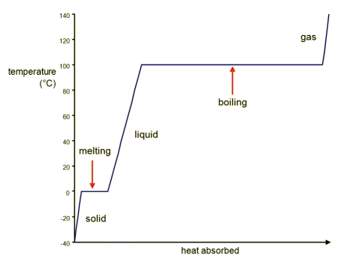
D
A
C
E
B
- What temperatures are represented by part A on the graph above? ___________________
- What state of matter is water in at these temperatures? ______________________
  - Write this state of matter next to A on the graph.

- What temperatures are represented by part B? ______________________
- What state of matter is water in at these temperatures? _______________________
  - Write this state of matter next to B on the graph.

- What temperatures are represented by part C? _____________________
- What state of matter is water in at these temperatures? _______________________
  - Write this state of matter next to C on the graph.

- Explain in terms of temperature and heat what is happening at parts D and E on the graph.

- Why do you think the graph looks like this at these points?

**Key Point:

Think about the equation for heat energy (Q=C•m•ΔT). Why doesn’t this equation work during parts D and E on the graph?

Types of Latent Heat:
EQUATIONS:
Heat of Vaporization (ΔH_{v}) =

Heat of Fusion (ΔH_{f})=

Practice: For Water: H_{f}= 334 J/g H_{v}= 2,260 J/g
- You want to melt 22 g of ice.
  - Where is this phase change located on the graph on the front of the worksheet? _____________
  - What equation needs to be used to calculate the heat needed to complete this phase change?
  - Calculate.

- You’re now boiling 286 grams of water to make tea.
  - Where is this phase change located on the graph on the front of this worksheet? _____________
  - What equation needs to be used to calculate the heat needed to complete this phase change?
  - Calculate.

Substance | H_{f}(J/g) | H_{V}(J/g) | Cp(J/g°C)
Copper | 205 | 4,726 | 0.387
Ethyl alcohol | 109 | 879 | 2.45
Gold | 64.5 | 1,578 | 0.129
Lead | 24.7 | 858 | 0.128
Silver | 88 | 2,300 | 0.233

- How much heat is needed to vaporize a 3.7 g sample of ethyl alcohol?

- How much heat is required to boil 6.2 g of gold?

- How much heat is needed to melt 2.3 g of silver?

- CHALLENGE! If it takes 5,449.8 J of energy to vaporize some amount of ethyl alcohol, how much ethyl alcohol do you have?

