Name:___________________________________ Date:_____________ Period:_______________
UNIT 2: Test Review
Objective 1: Defining Energy
1. What is energy?

2. What is the difference between heat and thermal energy?

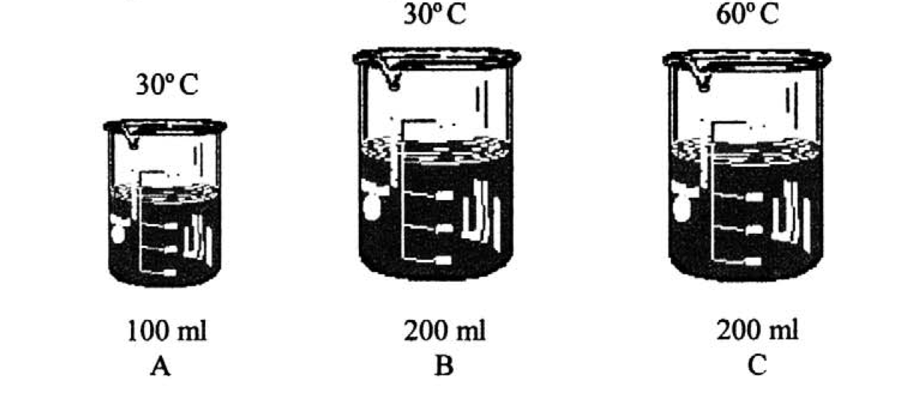
3. Order the beakers to the right in order from most to least thermal energy. Explain your reasoning.

4. If beaker A and beaker C were connected, in which direction would heat flow? How do you know?

5. Put the following in order from most heat energy to least heat energy: a large pot of boiling water, a life-sized ice sculpture of an elephant, a cup of hot chocolate, an ice cube. Explain your answer in at least one sentence.

Objective 2: Specific Heat
6. The specific heat of water is 4.18 J/g*⁰C. What does that mean, in terms of the energy required to heat up a particular amount of water?

7. Heat always flows from _________________ to ____________________.

8. If a 144.0 g sample absorbs 200 J of energy when heated from 3⁰C to 47⁰C, what is its specific heat? Show all of your work in your calculation!!!

9. The higher an object’s specific heat, the _____________________________ it heats up and cools down.

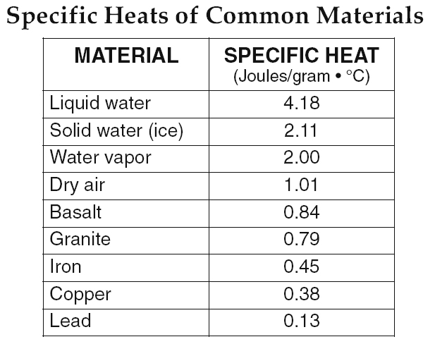
10. Based on the table to the right, place the following materials in order from requiring the least energy to heat up to requiring the most energy to heat up: Water vapor, dry air, granite, lead, & iron.

11. If you had 40 g of each substance in the table at 50ºC, which would have the least energy? Why?

12. Which substance would warm up fastest on a 60ºC day? Why?

13. Which substance would cool the slowest on a OºC day? Why?

Objective 3: Endothermic and Exothermic Reactions
14. In an exothermic reaction, heat is (released or absorbed).

15. In an endothermic reaction, heat is (released or absorbed).

16. After mixing two unknown samples in a test tube, it feels warm to the touch. What type of reaction is this? How do you know?

17. After mixing two unknown samples in a test tube, it feels cool to the touch. What type of reaction is this? How do you know?

18. Label each phase change as endothermic or exothermic:
a. Melting_______________________________
b. Freezing______________________________
c. Condensing___________________________
d. Vaporization_________________________
e. Sublimation__________________________
f. Deposition___________________________

Objective 4: Calculating Heat Using Specific Heat, Mass, and Temperature. Q = mcΔT
Show ALL OF YOUR WORK for both calculations. Specific heat of water is 4.18 J/gºC.
19. How much heat is lost if a 42.0 g sample of water is cooled from 127⁰C to 63⁰C?

20. What is the mass of a sample of water that gains 1000 J of heat when heated from 64⁰C to 74⁰C?

21. (Honors ONLY) You have 22 grams of gold (specific heat 0.129 J/gºC) at an initial temperature of 22.0ºC. If 2150 J of energy is added to the sample, what will be the final temperature?

Objective 5: Heat of Fusion and Heat of Vaporization
22. What is latent heat?

Given the following information for water: H_{f}= 334 J/g H_{v}= 2,260 J/g, C_{p} = 4.18 J/g⁰C.
23. Calculate the heat needed to melt 10 g of water.

24. Calculate the heat absorbed when the same 10 g sample of water boils.

Given the following information for gold: H_{f}= 64.5 J/g, H_{v}= 1,578 J/g, C_{p} = 0.129 J/g⁰C.
25. Calculate the heat lost when a 11.3 g sample of gold is frozen.

26. Calculate the heat required to vaporize the same 11.3 g sample of gold.

Objective 6. Reading a Heating Curve (Skills)
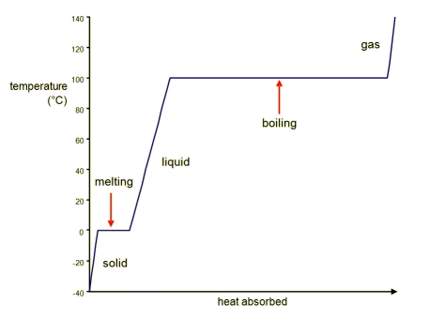

27. In this graph, heat energy is being ____________________________. How can you tell?

28. How are phase changes represented on the graph? Why do phase changes appear this way? Label the phase changes present on this graph.

29. During a phase change, which phases are present? Identify all phases present during each phase change. Label the phases of matter present on this graph.

30. According to the graph, as phases change from solid to liquid, heat is absorbed. What happens as phases change from liquid to solid?

Additional Skills Practice: (Not required!)
31. At which temperature does the substance transition between the solid state and liquid state?

32. What state or states of matter are present at point B on the graph? Explain your answer.

33. What state or states of matter are present at point D on the graph? Explain your answer.

