Name ___________________________________________________________ Date __________________________ Period ______
CLASSWORK: Heat, Thermal Energy, and Temperature
Part A: Inquiry Demo
Time (min) | Temperature of Beaker A (°C) | Beaker A observations | Temperature of Beaker B (°C) | Beaker B observations
Initial
1
2
3
4
5
Predict & Explain:
Beaker A has 100 mL of water at room temperature. Beaker B has 500 mL of water at room temperature. If both beakers are placed on a hot plate at the same time will the temperature change at the same rate in each beaker, or will it be different? Explain your thinking.

Observe:
Analysis Questions:
- Which beaker, Beaker A or Beaker B, holds more grams of water?

- Did both beakers receive the same amount of energy from the hot plate? Explain your reasoning.

- Did the beakers change temperature at the same rate? If not, which one changed temperature the fastest?

Part B: Notes – Heat vs. Temperature
What is the difference between thermal energy, heat, and temperature?
 | Thermal Energy | Heat | Temperature
Definition
Symbol
Common Units
Temperature is related to ______________________________________________________________________________________.
Example:

Heat:
Examples: Draw an arrow showing the direction of heat transfer in each of the following scenarios:
a. water with ice cubes b. beakers on a hot plate c. person running in the
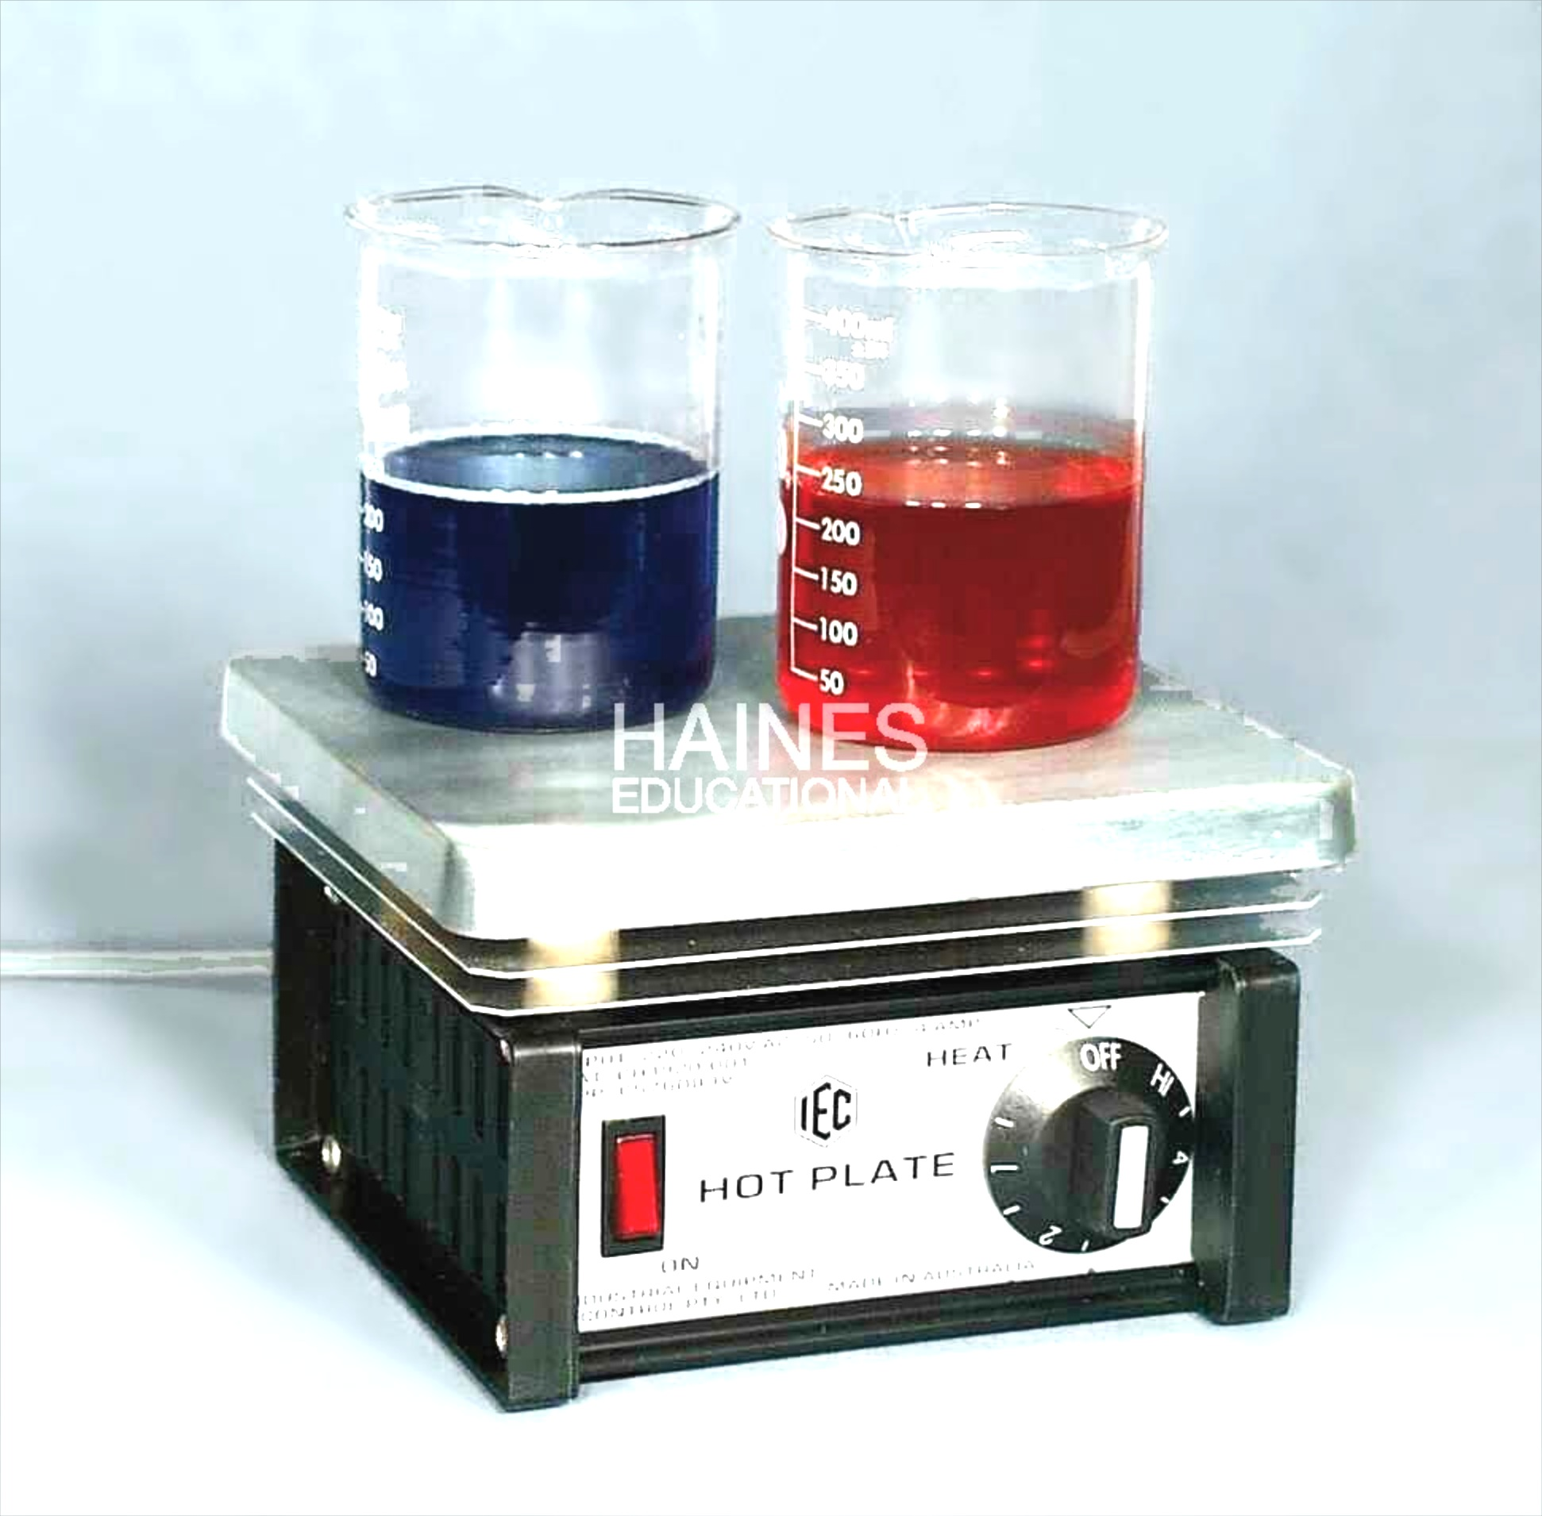
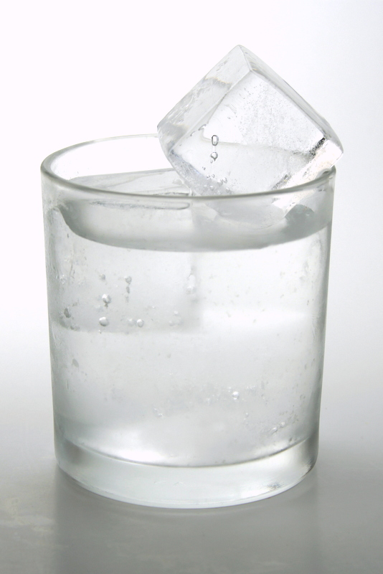
winter
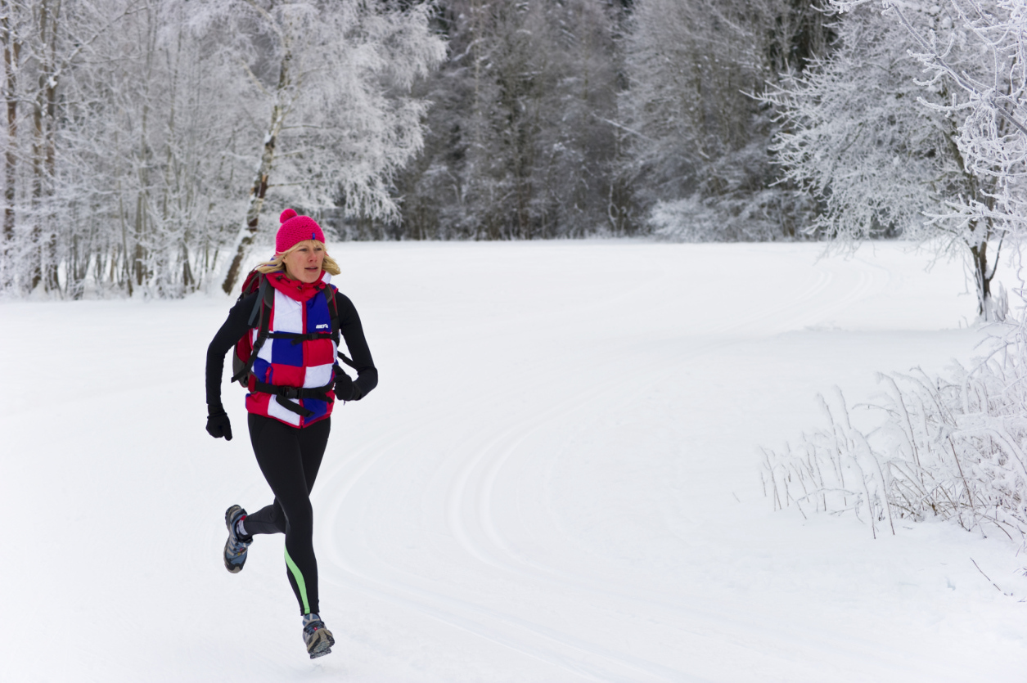

Practice Questions:
Use the following diagram to answer questions 1-3.
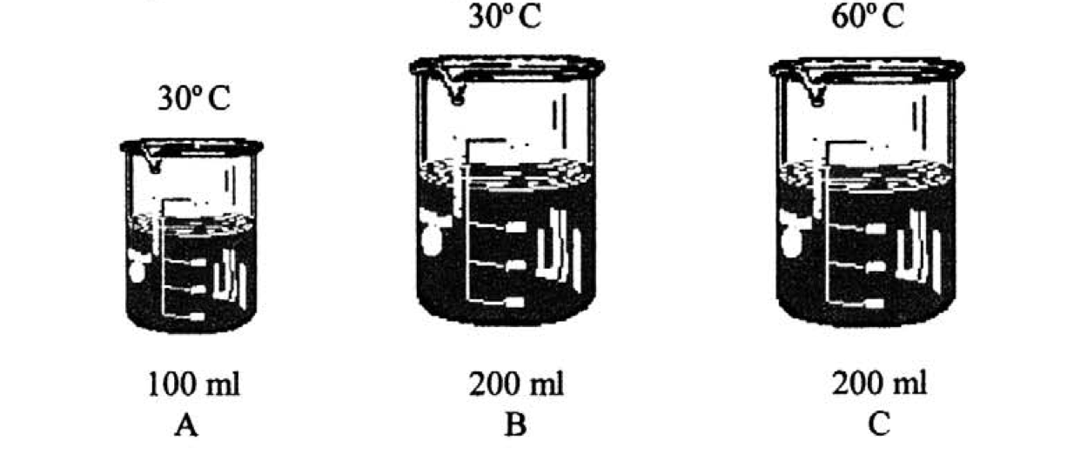

- In which container(s) is heat the greatest? _____________________
- In which 2 containers is the motion of molecules the same? _______________________
- Compare the motion of the molecules from beaker A to beaker C. Hint: Think back to the demo with food coloring in class.

- Fill out the following table. If there is a heat transfer between example A and B draw and arrow between the two pictures showing the direction of the heat transfer.
A | B | How do the temperatures compare? | How do the thermal energies compare?
Beaker of Water  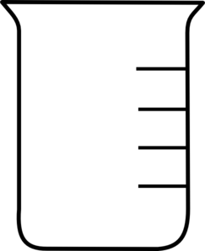  50 mL; 50 °C | Beaker of Water  50 mL; 100 °C
Beaker of Water  50 mL; 50 °C | Beaker of Water  25 mL; 50 °C
Aluminum Cube  15 cm³ ; 25 °C | Aluminum Cube  45 cm³ ; 25 °C
Aluminum Cube  15 cm³ ; 82 °C | Aluminum Cube  15 cm³ ; 62 °C

