Name ________________________________________ Date _________________________________ Period _________
CLASSWORK: Introduction to Specific Heat
Heating Substances in the sun: The following table shows the temperature after 10.0 g of 4 different substances have been in direction sunlight for up to 60 minutes.
Time (minutes) | Air (°C) | Water (°C) | Sand (°C) | Metal (°C)
O (initial) | 25°C | 25°C | 25°C | 25°C
15.0 min | 28.9°C | 26.2°C | 30°C | 35°C
30.0 min | 32.5°C | 27.5°C | 35°C | 45°C
45.0 min | 36.2°C | 28.8°C | 40°C | 55°C
60.0 min | 40°C | 30°C | 45°C | 65°C

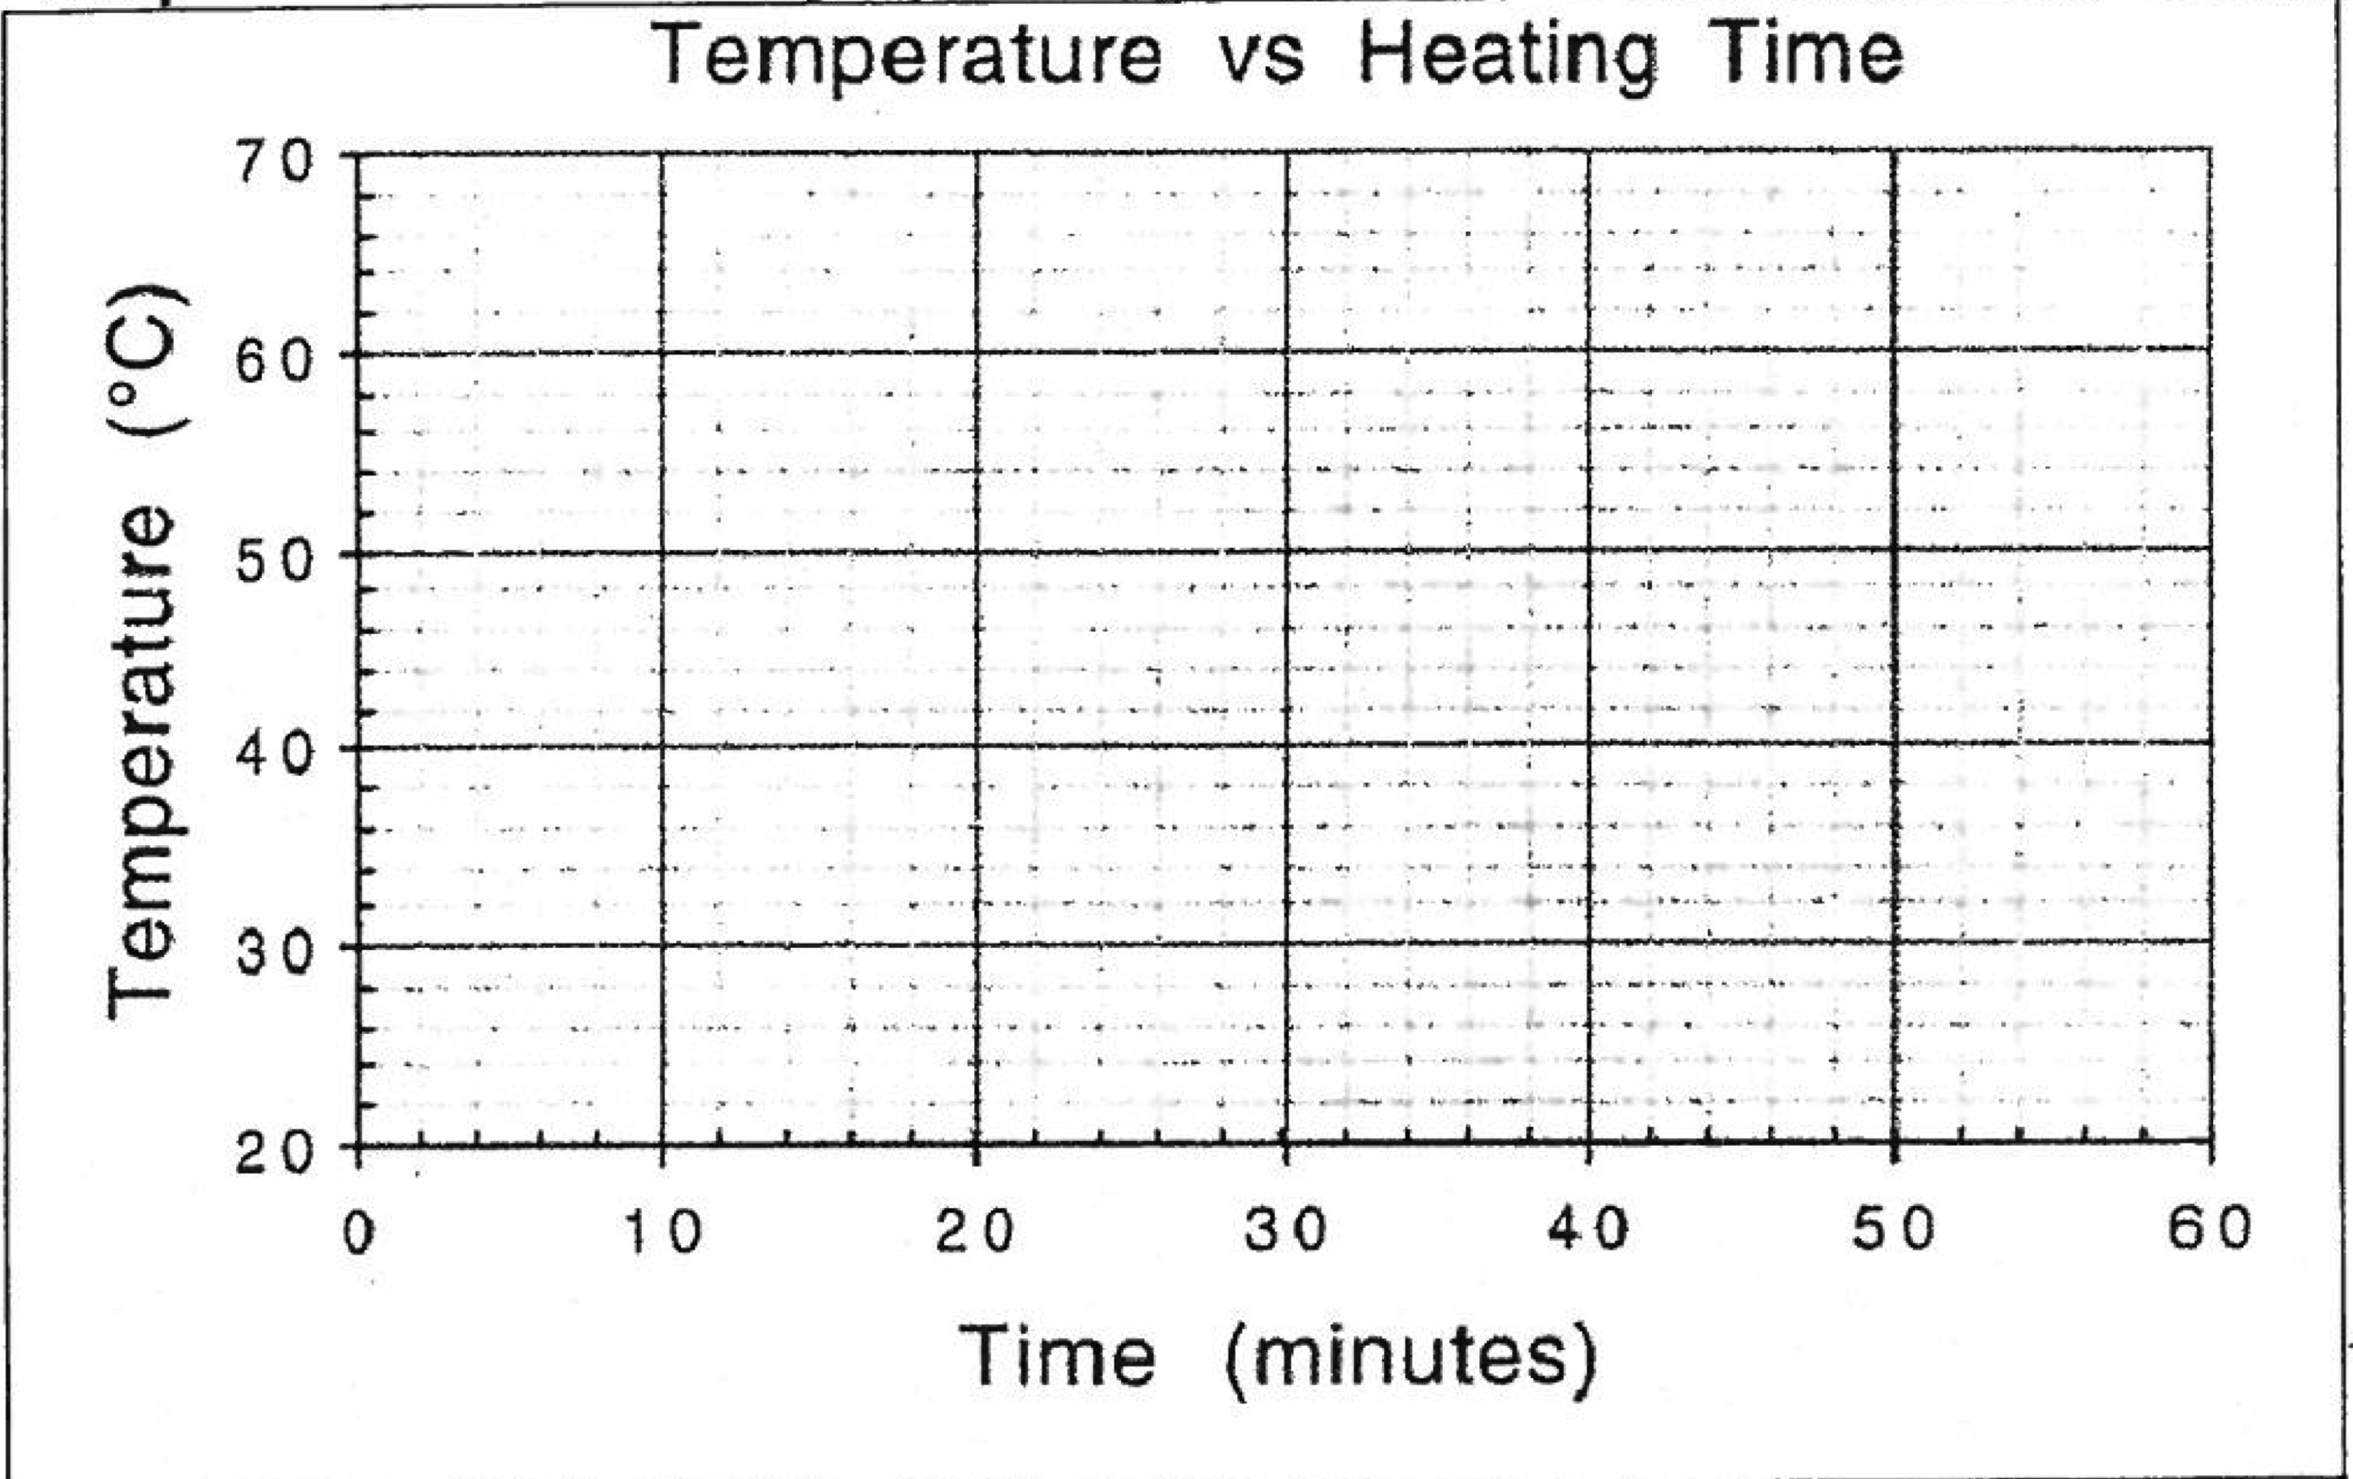
Step 1: Create a line graph for each substance on the graph below. Label the substances.

Step 2: Answer Questions
1. Order the substance based on the time required to heat them from:
Slowest

Fastest
2. Which do you think will cool the fastest? Explain.

3. When you boil water in a pot on the stove, which heats faster, the metal or the water? Explain.

4. Why do you think different substance heat up and cool down at different rates?

***Specific heat capacity = the amount of heat energy needed to raise the temperature of 1 g of a substance by 1 degree. ****
5. Based on the definition above, which of the 4 substances do you think has:
a) the highest heat capacity? b) the lowest heat capacity?

6. Here are the heat capacities of the four substances: 4.18 J/g °C, 1.00 J/g°C, 0.80 J/g°C, & 0.60 J/g°C. Match and then label each substance with its specific heat capacity on the graph.

7. If something has a high specific heat capacity will it take a lot of heat or a little heat to change its temperature? Explain. (careful! Use the definition, your graph and the data from #6)

8. Assuming they both start at the same temperature, which will heat up faster, a swimming pool or a bath tub? Explain your thinking.
Name ________________________________________ Date _________________________________ Period _________
NOTES: Specific Heat
Equation for Specific Heat: Q
C = m x ΔT

What does specific heat tell us?

Other ways to write the equation:
To solve for amount of heat: | To solve for mass: | To solve for temperature change:
Practice:
- Gold has a specific heat of 0.129 J/g°C). How man joules of heat energy are required to raise the temperature of 15 grams of gold from 22°C to 85°C?

Q=
C=
m=
ΔT=

- An unknown substance with a mass of 100 grams absorbs 1000 J of heat energy while undergoing a temperature increase of 15°C. What is the specific heat of the substace?

Q=
C=
m=
ΔT=

- If the temperature of a 34.4 g of ethanol increases from 25°C to 78.8°C, how much heat has been absorbed by the ethanol? The specific heat of ethanol is 2.44 J/g°C)

Q=
C=
m=
ΔT=

- Graphite has a specific heat of 0.709 J/g°C. If a 25 gram piece of graphite is cooled from 35°C to 18°C, how much energy was lost by the graphite?

Q=
C=
m=
ΔT=

