Name ________________________________________ Date _________________________________ Period _________
CLASSWORK: Bomb Calorimeter Skills Practice
Test Tips:
- Step 1: Always read the questions FIRST!
  - If a question asks about a specific table or figure, make note of that in the passage.
  - Identify key parts of the question as you read it. Make sure you know exactly what you are looking for.
- Step 2: Look for patterns in the data. Draw arrows to identify increasing/decreasing trends.
- Step 3: Use the data to help you answer questions about the data.
- Step 4: For any unanswered questions, look to the passage to find your answer.

Questions:
1. Based on the data in Table 1, as the change in water temperature increased, heat released:
a. Increased b. Decreased
c. Stayed the same d. There is not enough information.

2. According to Tables 1 and 2, as the mass of each additional sucrose sample increased, the change in the water temperature produced when the sample was burned most likely:
a. Increased only. b. Decreased only.
c. Increased, then decreased. d. Remained the same.
3. Based on the data in Table 2, one can conclude that when the mass of sucrose is decreased by one- half, the amount of heat released when it is burned in a bomb calorimeter will:
a. Increase by one-half b. Decrease by one-half
c. Increase by one-fourth d. Decrease by one-fourth

4. Which of the following graphs best illustrates the relationship between the heat released by the foods listed in Table 1 and the change in water temperature?
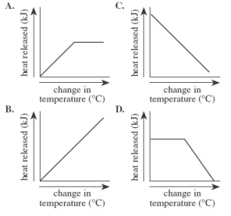

5. Which of the following lists the foods from Table 1 and 2 in increasing order of the amount of heat released per gram of food?
a. Potato, egg, bread, sucrose, cheese b. Sucrose, cheese, bread, egg, potato
c. Bread, cheese, egg, potato, sucrose d. Sucrose, potato, egg, bread, cheese

6. According to the passage, what is the purpose of a bomb calorimeter?
a. To calculate the amount of calories present in the substance.
b. To determine the amount of heat released when a substance is burned in oxygen.
c. To determine the number of particles present in a substance.
d. To calculate kinetic and potential energy in a substance.
Passage:
A bomb calorimeter is used to determine the amount of heat released when a substance is burned in oxygen (figure 1). The heat, measured in kilojoules (kJ), is calculated from the change in temperature of the water in the bomb calorimeter. Table 1 shows the amounts of heat released when different foods were burned in a bomb calorimeter. Table 2 shows the amounts of heat released when different amounts of sucrose (table sugar) were burned.
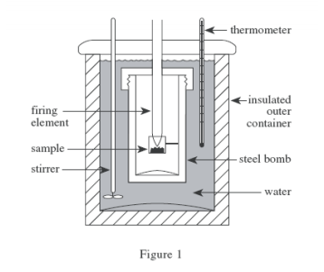

BEFORE YOU READLook for patterns and trends.
Figure 1: What is going on in this figure?

_____________________________________________________________________________________________________________________________________________________________________________________________________________________________________________________

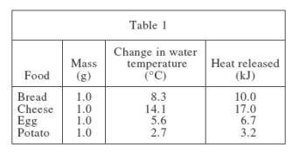

Table 1: What trend do you notice? HINT: Items are not always in an increasing/decreasing order. There may be a pattern if you rearrange the rows.
__________________________________________________________________________________________________________________________________________________________________________________________________________________________________________________________________________________________________

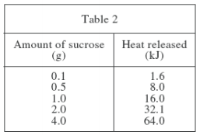
Table 2: What trend do you notice? Is there any relationship between the data in Table 1 and Table 2?
__________________________________________________________________ __________________________________________________________________ __________________________________________________________________ __________________________________________________________________ __________________________________________________________________ __________________________________________________________________ __________________________________________________________________ __________________________________________________________________

Timed Skills Practice
Using the same data from above, answer the following questions in 5 minutes.

1. Based on the data in Table 2, if a new trial was run, and the amount of heat released was 128 kJ, what is the best estimate of the amount of sucrose in the sample?
a. 3.0
b. 5.0
c. 8.0
d. 40

2. According to the passage, how is heat calculated?
a. Measuring change in temperature of the calorimeter.
b. Measuring steam produced by the calorimeter.
c. Measuring the amount of sucrose in the sample.
d. There is not enough information to determine.

3. According to Tables 1 and 2, what is the closest estimate for the amount of sucrose in cheese?
a. Greater than 4.0g
b. Less than 0.1 g
c. Between 0.5 g and 1.0 g
d. Greater than 1.0 g but less than 2.0 g

4. Based on the information in Tables 1 and 2, the heat released from the burning of 5.0 g of potato in a bomb calorimeter would be closest to which of the following?
a. 5 kJ
b. 10 kJ
c. 15 kJ
d. 20 kJ

5. If another trial was added to Table 1 showing data for a turnip being burned in the calorimeter, what is the most reasonable estimate for the food item it would most closely resemble?
a. A potato, because turnips are similar food items to potatoes.
b. Bread, because both turnips and bread are the same color.
c. Cheese, because both turnips and cheese are milk products.
d. Eggs, because both turnips and eggs have similar shapes.

