Name ____________________________________________________________ Date ________________________ Period _________
CLASSWORK: Lewis Dot Structures and Isotopes
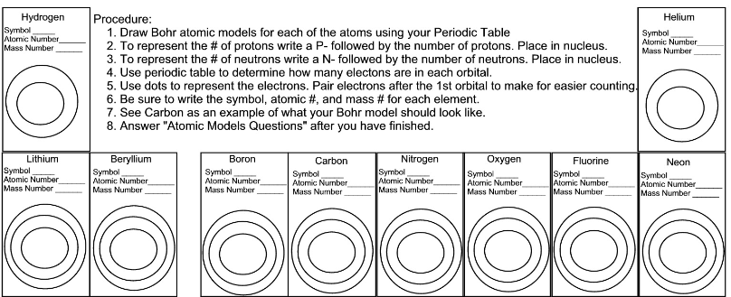
Follow the directions to finish the models below:

We can draw a Bohr model of the atom and we can identify the valence electrons by groups. Valance electrons are so important we can also draw them their own structure called a Lewis Dot Structure.
To draw the Lewis dot structures ______________________________________________________________________________ ______________________________________________________________________________________________________.
EXAMPLE: Hydrogen has one electron in its outer shell and would be drawn
Draw the Lewis structures for the following elements:
Helium (Valence = ____) | Lithium (Valence = ____) | Beryllium (Valence = ____) | Boron (Valence = ____)
Carbon (Valence = ____) | Nitrogen (Valence = ____) | Oxygen (Valence = ____) | Fluorine (Valence = ____)
Neon (Valence = ____) | Krypton (Valence = ____) | Potassium (Valence = ____) | Arsenic (Valence = ____)
Francium (Valence = ___) | Tin (Valence = ____) | Bromine (Valence = ____) | Iodine (Valence = ____)
Sulfur (Valence = ____) | Selenium (Valence = ___) | Tellurium (Valence = ____) | Polonium (Valence = ____)
Are the trends for Lewis structures similar to the ones that we identified for the Bohr model? Explain.
67

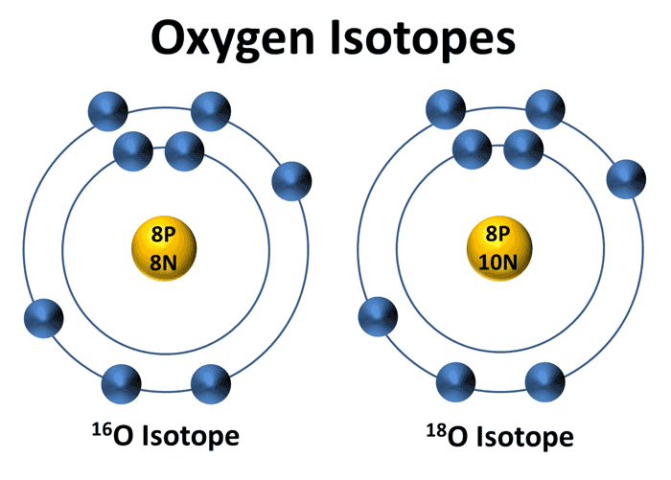
What do you notice is different about the two atoms of Oxygen to the left?
Oxygen-16
Oxygen-18

What is the atomic mass of each atom?

Can the number of protons in an atom of an element be different?

Where does the name of each atom come from?

The number of protons in the nucleus of a specific element cannot change, but the number of neutrons can. The chlorine atoms that are most commonly found are:
Chlorine-35 has protons electrons neutrons
Chlorine-36 has protons electrons neutrons
***KEY POINT:

How to Write an Isotope:
Symbol Notation
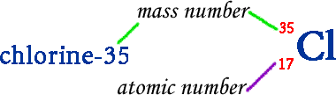
- Write the mass and the atomic number on the left side of the symbol
- Write the mass on the top, atomic number on the bottom.

Isotope Notation
- Write the name of the element
- Write the mass number of the isotope after it.

Practice
Isotope  Notation | Symbol  Notation | Atomic # | Protons | Electrons | Neutrons | Mass Number
Oxygen-16
 | ⁸⁰₃₅Br
Uranium-235
 | ²³⁸₉₂U
 |  | 80 |  |  |  | 201
 |  |  | 26 |  |  | 58
 |  |  | 49 |  | 66

