Name ___________________________________________ Date __________________________________ Period ________
READING: Dalton’s Atomic Theory
Early Models of the Atom
Have you ever been asked to believe in something you couldn’t see? Using your unaided eyes, you cannot see the tiny fundamental particles that make up matter. Yet all matter is composed of such particles, which are called atoms. An atom is the smallest particle of an element that retains its identity in a chemical reaction.

The concept of the atom intrigued a number of early scholars. Although these philosophers and scientists could not observe individual atoms, they still were able to propose ideas on the structure of atoms.
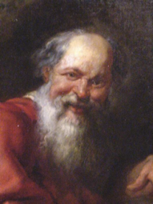
Figure 1. Democritus believed that matter consisted of tiny, indivisible, unchangeable particles called atoms. The Greek philosophers Plato and Aristotle later challenged his ideas.
Democritus’s Atomic Philosophy
The Greek philosopher Democritus (460 B.C. – 370 B.C.) was among the first to suggest the existence of atoms. Democritus believed that atoms were indivisible and indestructible. Although Democritus’s ideas agreed with later scientific theory, they did not explain chemical behavior. They also lacked experimental support because Democritus’s approach was not based on the scientific method.

Early science was very similar to hallway gossip. The Greek and Roman philosophers debated, discussed, and sometimes even attacked one another. But the mode of discovery was talk. There was no experimentation –the idea had not been thought of yet. So science did not develop very far and there was no reliable way to establish what was true and what was false.

John Dalton
While it must be assumed that many more scientists, philosophers and others studied the composition of matter after Democritus, a major leap forward in our understanding of the composition of matter took place in the 1800s with the work of the British scientist John Dalton. He started teaching school at age twelve, and was primarily known as a teacher. In his twenties, he moved to the growing city of Manchester, where he was able to pursue some scientific studies. His work in several areas of science brought him a number of honors. When he died, over 40,000 people in Manchester marched at his funeral.
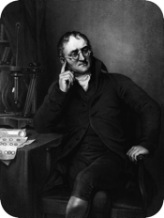
Figure 2. John Dalton began the modern process of discovery regarding atoms.

Dalton studied the weights of various elements and compounds. He noticed that matter always combined in fixed ratios based on weight, or volume in the case of gases. Chemical compounds always contain the same proportion of elements by mass, regardless of amount, which provided further support for Proust’s law of definite proportions. Dalton also observed that there could be more than one combination of two elements.

Dalton’s Atomic Theory (1804)
From his experiments and observations, as well as the work from peers of his time, Dalton proposed a new theory of the atom. This later became known as Dalton’s atomic theory. The general tenets of this theory were as follows:
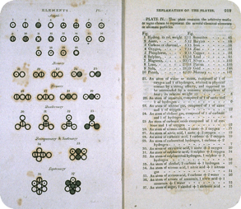
Figure 3. Dalton’s symbols from his book, A New System of Chemical Philosophy.
- All matter is composed of extremely small particles called atoms.
- Atoms of the same element are identical in size, mass, and other properties. Atoms of different elements differ in size, mass, and other properties.
- Atoms cannot be subdivided, created, or destroyed.
- Atoms of different elements can combine in simple whole number ratios to form chemical compounds.
- In chemical reactions, atoms are combined, separated, or rearranged

Dalton’s Atomic Theory Today
The scientific community, with the exception of three changes, has largely accepted Dalton’s atomic theory. We know now that (1) an atom can be further sub-divided into smaller sub-atomic particles: protons, neutrons and electrons, (2) all atoms of an element are not identical in mass, isotopes are atoms of the same element with different masses, and (3) using nuclear fission and fusion techniques, we can create or destroy atoms by changing them into other atoms.

Review Questions:
- What did Democritus believe about atoms?

- How was John Dalton’s process for discovery atoms different than Democritus’s?

- IN YOUR OWN WORDS, list the components of Dalton’s Atomic Theory: (You will need to know these!)

- What parts of Dalton’s Theory are not considered valid any more?

- Because some of Dalton’s Theory has been disproven, do you think his contribution to science still matters? Why or why not?

