- Which subatomic particle in the atom has a neutral charge?

- Which subatomic particle in the atom determines the charge of the atom?

- Draw and label the atom making sure to include the nucleus, neutrons, electrons, and protons:

- How many protons are in an atom of Potassium?

- When comparing Selenium, Arsenic, and Bromine, which one has the least amount of neutrons?

- What is an isotope?

- How many neutrons are in Neon-22?

- Element X has four isotopes of equal abundance: ¹²⁰X, ¹²⁸X, ¹³²X, and ¹³⁶X. If the average atomic mass is 135.4, which of the isotopes is most abundant?

- How do elements, compounds, and mixtures differ?

- Label the pictures below as an element, compound, or mixture: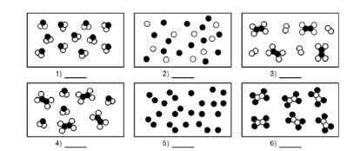

- Draw the Bohr model for Nitrogen:

- How many valence electrons are in a carbon atom?

- An atom has 30 total electrons. How many of those electrons are valence electrons?

- What is an ion and how is it formed?

- What is the charge Selenium when it forms an ion?

- What is the charge of an ion that loses 3 electrons?

- How many moles are in 3.5g of NaOH?

- How many grams are in 3.05 x 10²⁴ atoms of zinc?

- How many atoms are in 10.5 grams of H₂O?

- How many grams are in 2.73 x 10²² molecules of CO₂?

