**Periodic Trends: Overview**

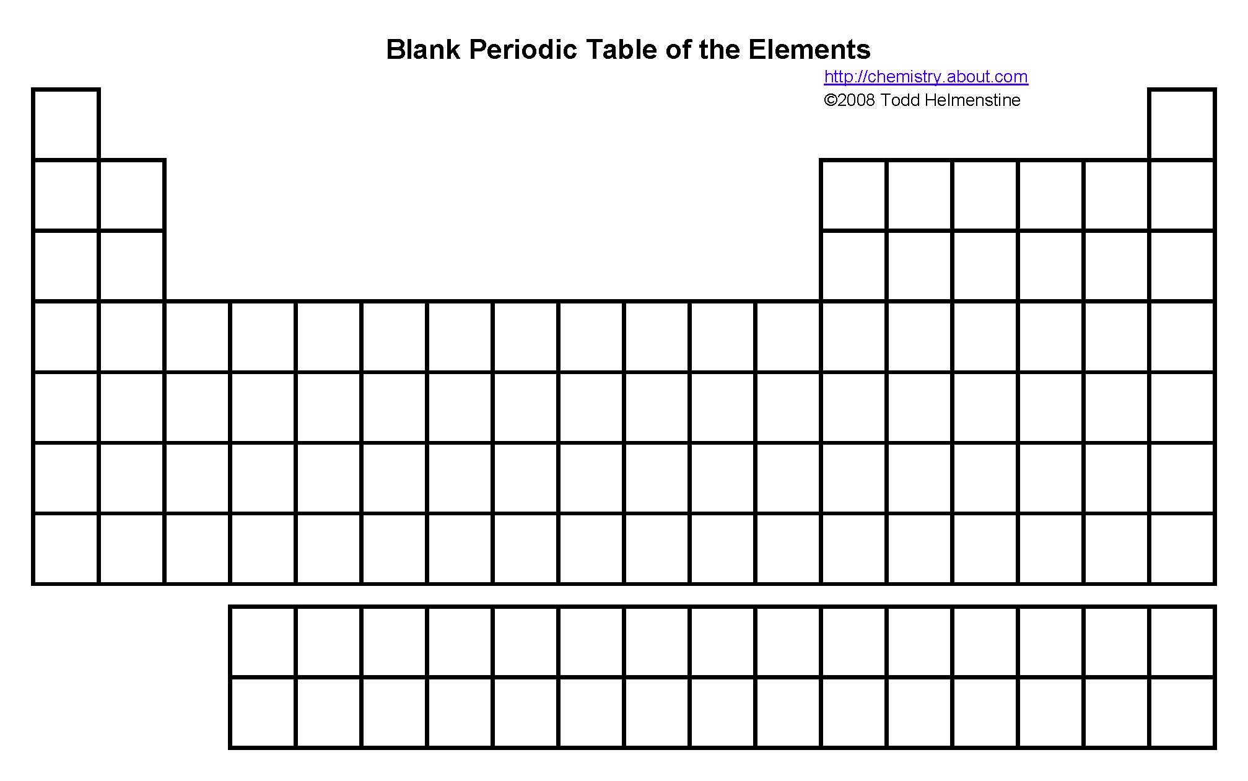****

-----------Transition Metals------------

Trend:

**KEY:**

**Periodic Trends: Atomic Radius**

|  |  |
| --- | --- |
| What does **atomic radius** mean? | What’s the trend on the periodic table?  As you go across a period…  As you go down a group…  The ***largest*** atomic radius is  The ***smallest*** atomic radius is |
| What causes this trend to occur? |

Use the following graph to answer the questions.

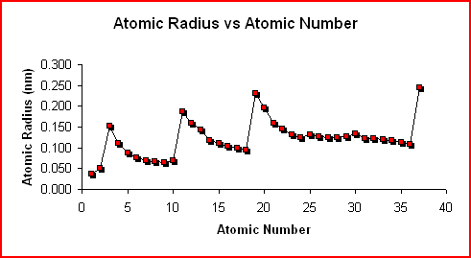

?

Using the Data/Skills Questions:

1. Which of the following describes the trend of data from the first 5 elements in the graph above? (IOD 404)

a. There is a sharp increase followed by a gradual decrease

b. There is a sharp increase followed by a sharp decrease

c. There is a sharp decrease followed by a gradual increase d. There is a gradual increase followed by a sharp increase then decrease

2. Which of the following scenarios is most likely to occur under the question mark on the graph? (IOD 503)

a. Dramatic increase in atomic radius only as atomic number increases.

b. Dramatic increase, then a decrease in atomic radius as atomic number increases.

c. Gradual increase in atomic radius as atomic number increases.

d. Gradual decrease, then a dramatic increase as the atomic number increases.

3. Which statement below is best supported by the data in the graph? (IOD 402)

a. Noble gases always have the lowest atomic radius.

b. A new row causes a sharp decrease in atomic radius

c. As protons and electrons are added across a period the size of an atom increases

d. Non-metals are commonly larger than metals in the same period

4. Looking at your periodic table and the graph, what conclusion could be made about the atomic radius of an element with the atomic number of 37? (IOD 603)

a. The atomic radius would be between 0.150 nm and 0.200 nm.

b. The atomic radius would be less than 0.05 nm.

c. The atomic radius would be between 0.100 nm and 0.150 nm.

d. The atomic radius would be greater than 0.200 nm.

5. Which of the following graphs would best represent the atomic radius data for period 2? (IOD 403)

A. 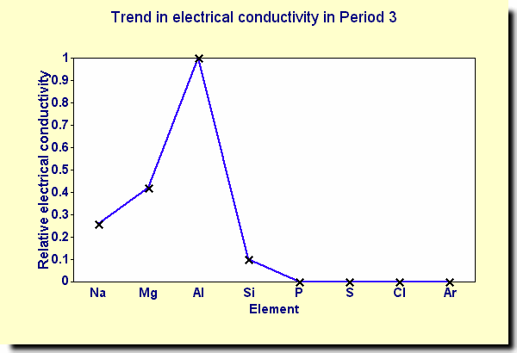 B. 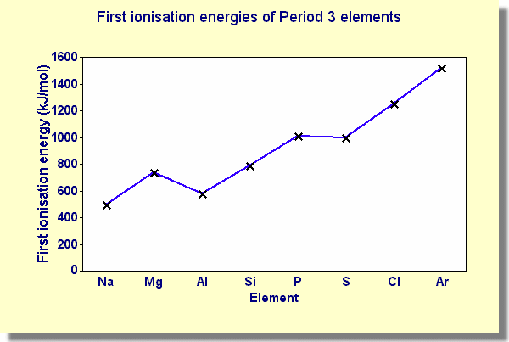

C. 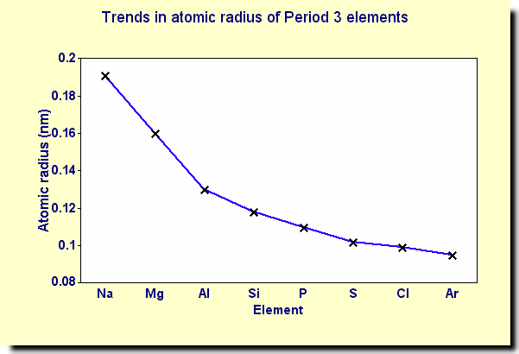 D. 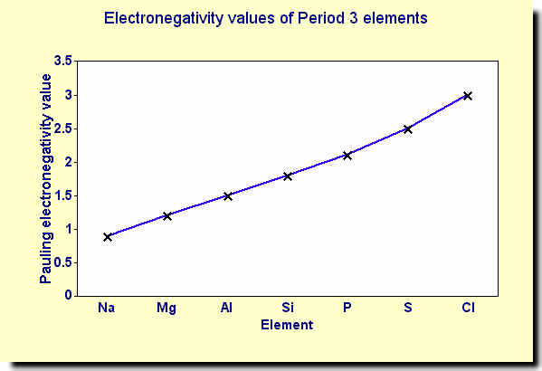

**Write:**

Given what you know about other elements on the periodic table, what can you predict about the atomic radius of cesium? Use specific data and reference the trend in your answer.

**Periodic Trends: Ionization Energy**

|  |  |
| --- | --- |
| What does **ionization energy** mean? | What’s the trend on the periodic table?  As you go across a period…  As you go down a group…  The ***largest*** atomic radius is  The ***smallest*** atomic radius is |
| What causes this trend to occur? |

Use the following graph to answer the questions.

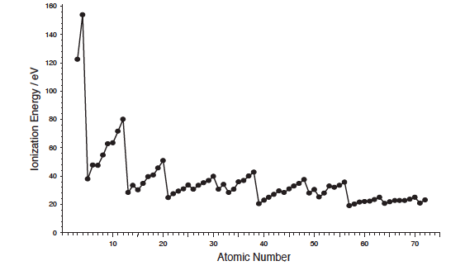

?

Atomic Number

**Skills Questions/Interpolation:**

1. According to the graph, the atom with an atomic number of 10 would need how much ionization energy to remove an electron? (IOD 301)

a. 24 eV

b. 60 eV

c. 80 eV

d. 36 eV

2. According to the graph, which atom below has the lowest ionization energy? (IOD 402)

a. K b. Ca

c. Ga d. Ge

3. If the trend was continued to an element with an atomic number of 50 the ionization energy would (IOD 404)

a. Increase

b. Decrease

c. Stay the same

d. Not enough information

4. Which of the following scenarios best describes what is occurring under the question mark on the graph? (IOD 603)

a. A sharp decrease followed by the ionization energy being held constant

b. A sharp increase followed by a sharp decrease of ionization energy

c. A sharp decrease followed by a steady increase of ionization energy

d. A constant increase followed by a sharp decrease of ionization energy

5. Which of the following graphs best represents the trend for ionization energy from atomic number 3 to atomic number 10. (IOD 403)

A. B. 

C.  D. 

**Write**:

Given what you know about other elements on the periodic table, what can you predict about the ionization energy of cesium? Use specific data and reference the trend in your answer.

**Periodic Trends: Electronegativity**

|  |  |
| --- | --- |
| What does **electronegativity** mean? | What’s the trend on the periodic table?  As you go across a period…  As you go down a group…  The ***largest*** atomic radius is  The ***smallest*** atomic radius is |
| What causes this trend to occur? |

Use the following graphs to answer the questions.

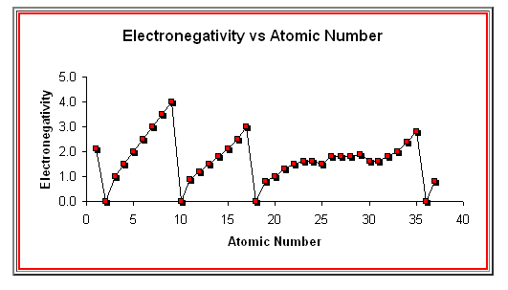**Skills Questions/Interpolation**

?

1.Which of the following correctly orders these elements from the second period in decreasing order of electronegativity use your periodic table to assist (IOD 501)

a. Lithium, Fluorine, Beryllium, Boron, Neon

b. Neon, Lithium, Beryllium, Boron, Fluorine

c. Fluorine, Boron, Beryllium, Lithium, Neon

d. Neon, Fluorine, Boron, Lithium, Beryllium

2. Using the information from the graph What would you expect the electronegativity to be for argon (IOD 603)

a. Between 3 and 4 b. Between 2 and 3

c. between 1 and 3 d. 0

3. A new element was discovered in the lab that was added element 117(millertinium) the scientist stated that the element had an electronegativity of 5.2 is their hypothesis correct? (EMI 401)

a. No, because new elements that are discovered do not have an electronegativity

b. No, because fluorine is the highest point of electronegativity and it decreases as atomic number increases

c. Yes, because new elements that are discovered all the time with new properties that disagree with older discoveries

d. Not enough information

4. Which of the following scenarios best describes what is occurring under the question mark on the graph? (IOD 603)

a. A sharp decrease followed by the electronegativity being held constant

b. A sharp decrease followed by a steady increase of electronegativity

c. Electronegativity is held constant for the entire box.

d. A constant increase followed by a sharp decrease of electronegativity

5. Determine which of the following best describe the values of ionization energy and electronegativity of noble gases. (IOD 501)

a. Ionization energy is the lowest and electronegativity is at its highest in the period

b. Ionization energy and electronegativity are at the highest in the period

c. Ionization energy and electronegativity are at the lowest in the period

d. Ionization energy is at its highest point while electronegativity are at the lowest point in   
the period

6. Which of the following best describes the overall trends for all three trends over the entire graph? (EMI 504)

a. Ionization energy and electronegativity increase, while atomic radius decrease

b. Ionization energy, electronegativity and atomic radius increase

c. Ionization energy, electronegativity and atomic radius decrease

d. Ionization energy and electronegativity decrease while atomic radius increase

**Write:**

Given what you know about other elements on the periodic table, what can you predict about the electronegativity of cesium? Use specific data and reference the trend in your answer.