Name ___________________________________________________ Date ____________________________________ Period ___________

**CLASSWORK: Defining Covalent Compounds**

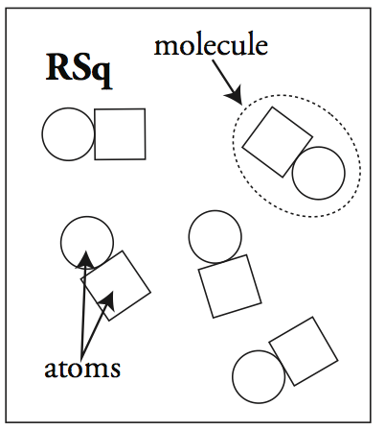**Review**. 1. Examine the pictures to the right. What’s the difference between a **compound** and a **molecule**?

2. What is a **chemical** **bond**?

3. Draw the Lewis Dot Structures for the following atoms:

C N P F Si O

4. If the atoms above wanted to bond (for example, carbon monoxide (CO)) would it work for them to transfer electrons from one atom to another like in an ionic bond? Why or why not?

5. Two fluorine atoms are often found bonded together. Based on the Lewis Dot structure you drew above, how do you think these atoms would combine together?

**Covalent Compounds**

All covalent compounds are composed of ________________________________________________________________________.

All nonmetals have ____________________________________________________________________________________________, so they want to ________________________________________________________________________________________________.

Therefore, the atoms in covalent compounds ____________________________________________________________________

By sharing electrons, ________________________________________________________________________________________________

|  |  |
| --- | --- |
| **Lewis Dot Structure** | **Bohr Model** |
| **🡪** |  |

**6. Practice**: Write **ionic**, **covalent**, or **neither** to identify the following compounds.

1. NO2 ________________________________ e. MgBr2 ________________________________
2. NaCl ________________________________ f. PO43- ________________________________
3. CaO ________________________________ g. H2O ________________________________
4. CuZn ________________________________ h. O2 ________________________________

**Properties of Covalent Compounds**

|  |  |  |
| --- | --- | --- |
| **Property** | **Ionic Compounds (Review)** | **Covalent Compounds** |
| Appearance |  |  |
| Melting/Boiling Point |  |  |
| Electrical Conductivity |  |  |
| Malleablity |  |  |

**Practice**

1. Gasoline has a relatively low boiling point, does not conduct electricity and is a liquid at room temperature. Is gasoline ionic or covalent, why?

2. You have a tablespoon of baking soda. You put it on the stove and it does not melt and you dissolve it in water and it will conduct electricity. What type of compound is baking soda? How do you know?

3. A mystery substance is a crystalline solid and room temperature, a low melting point and it does not conduct electricity. Can you determine for sure what type of compound this is? Why or why not?

**Multiple Bonds**

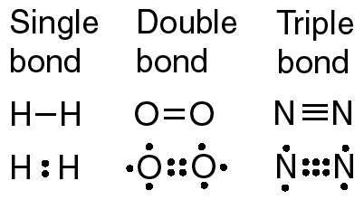Examine the covalent compounds to the left. What do you notice is different about them? Why do you think this is?

Single Bond:

Double Bond:

Triple Bond:

**Diatomic Molecules**

Diatomic molecules are _____________________________________________________________________________________________

The common diatomic elements are:

*How can I remember these?!?!*

1. B.