DO NOT WRITE ON THIS!!! – WRITE YOUR ANSWERS IN YOUR NOTEBOOK!!!
GROUPWORK: Nonpolar, Polar, and Ionic Bonds

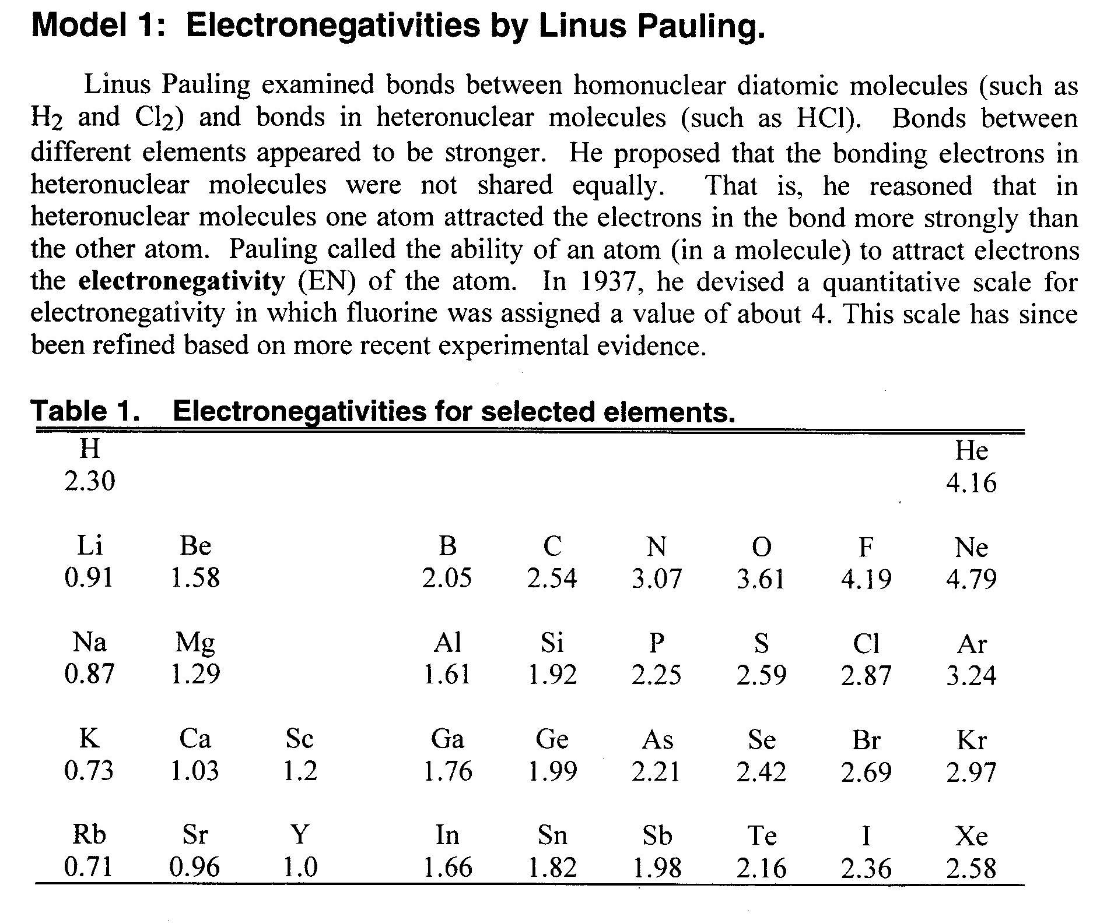
READ THIS: Electronegativity is a measure of how much an atom attracts an electron: the higher the electronegativity, the greater the atom’s attraction to electrons. You can think of atoms pulling on electrons like a “tug-of-war”. Atoms with a higher electronegativity can pull harder on electrons than atoms with low electronegativities. Atoms that become negative ions have a much greater electronegativity than atoms that become positive ions. Below is a table of the electronegativities of many elements from the periodic table.

- Describe the trend in electronegativities as one moves from left to right across a period of the periodic table.
- Describe the trend in electronegativities as one moves down a group of the periodic table.
- Excluding the inert (or noble gases), which three elements have the highest electronegativities?
- Hydrogen and bromine can form a covalent bond. However, electrons are not equally within this bond. Which atom, hydrogen or bromine, would have a stronger pull on the shared electrons?
- Without referring to the table of electronegativities, identify the most electronegative atom in each case:
  - Al, P, S, Se, Te
  - P, Sr, Cu, As, Pb
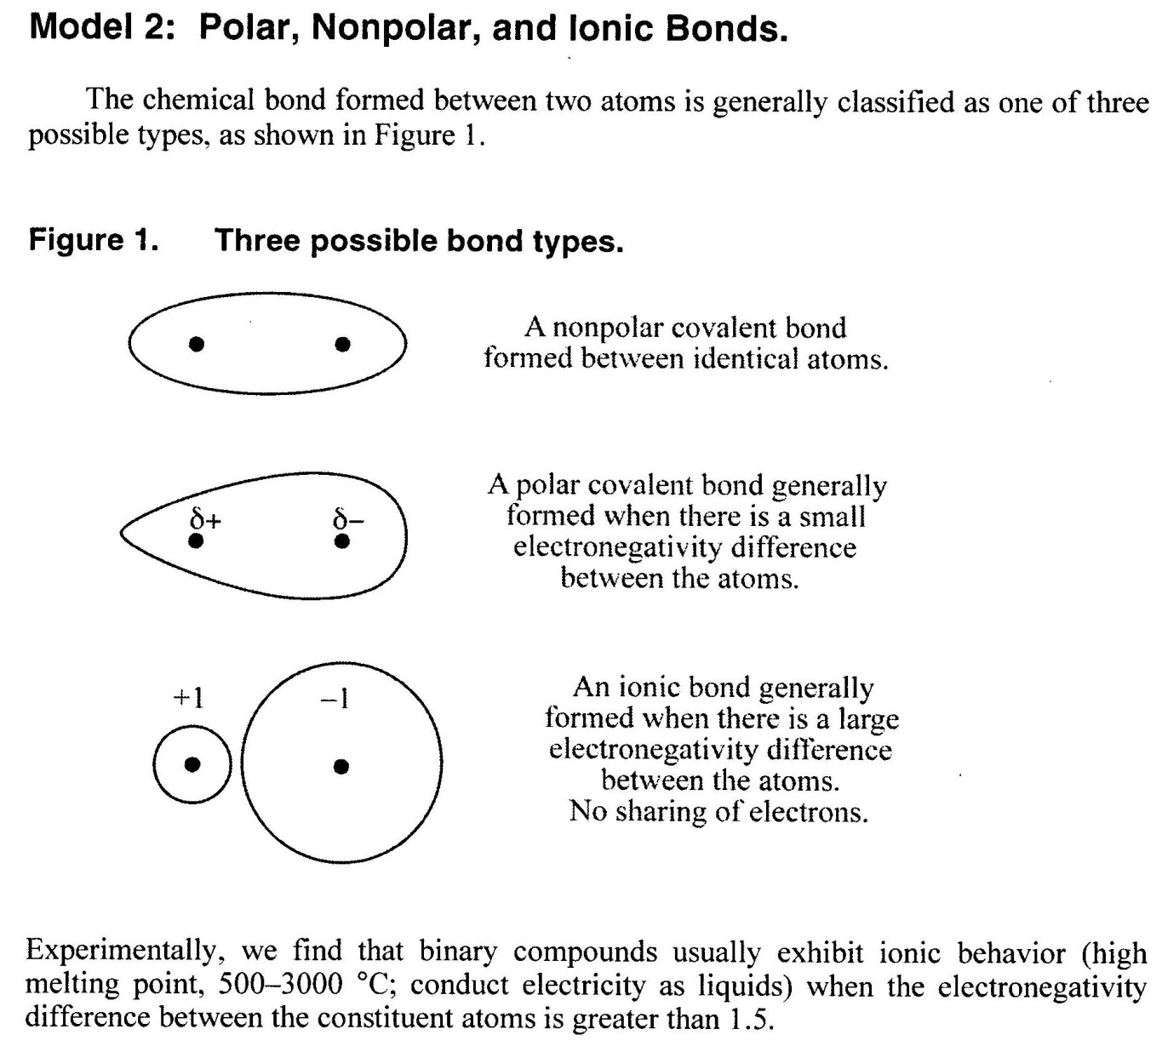

Electronegativity Difference | Type of Bond
0.0-0.4 | Nonpolar Covalent
0.5-1.9 | Polar Covalent
1.5 ≤ | Ionic

- Chlorine forms a diatomic molecule, which means it naturally occurs as Cl₂ in nature.
  - Draw the Lewis dot structure for Cl₂.
  - Is this molecule nonpolar covalent, polar covalent, or ionic? Why?
  - Model 2 shows you what the electron clouds look like around the atoms in nonpolar covalent, polar covalent, and ionic bonds. Based on your answer to 6b, draw the electron cloud around the Lewis dot structure you drew in part 6a.

- Hydrochloric acid (HCl) is a strong acid found in your stomach to break down the food you eat.
  - Draw the Lewis dot structure for HCl.
  - Is this molecule nonpolar covalent, polar covalent, or ionic? Why?
  - Would electrons spend more time around the hydrogen atom or the chlorine atom in this molecule? Why?
  - Based on your answers to both 7b and 7c, draw the electron cloud around the Lewis dot structure you drew in 7a.

- Sodium chloride (NaCl) is the compound that makes up table salt.
  - Draw the Lewis dot structure for NaCl.
  - Is this molecule nonpolar covalent, polar covalent, or ionic? Why?
  - Based on your answers to both 8b and 8c, draw the electron cloud around the Lewis dot structure you drew in 8

- Thinking back to the example of electronegativity and “tug-of war”, why do molecules like H₂, Cl₂, N₂, etc. have nonpolar bonds?
- Which bond is more polar—a phosphorus-chlorine bond or a phosphorus-fluorine bond? Explain why.
- Consider a carbon-chlorine bond. One atom in the bond is “partially negative” and the other atom is “partially positive”. Which atom is which? Explain.
- Consider a carbon-hydrogen bond. One atom in the bond is “partially negative” and the other atom is “partially positive”. Which atom is which? Explain.
- For the following compounds, indicate whether they would have ionic, polar covalent, or nonpolar covalent bonds. Show your electronegativity comparisons to help defend your answer!
a) CP b) SO c) BeO d) NO e) MgS f) HBr h) OF

