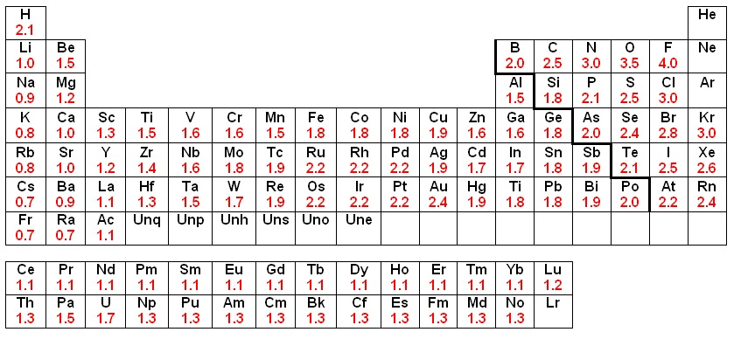

**Prefixes for Molecular Names**

|  |  |
| --- | --- |
| **Prefix** | **Number** |
| mono-  di-  tri-  tetra-  penta-  hexa-  hepta-  octa-  nona-  deca- | 1  2  3  4  5  6  7  8  9  10 |

**Element Electronegativities**

**Common Transition Metal Charges**

|  |  |
| --- | --- |
| **Formula** | **Name** |
| Cu1+  Cu2+  Fe2+  Fe3+  Hg22+  Hg2+  Pb2+  Pb4+  Sn2+  Sn4+  Cr2+  Cr3+  Mn2+  Mn3+  Co2+  Co3+  Zn2+  Ni2+  Ni3+  Ag1+ | Copper (II) ion  Copper (III) ion  Iron (II) ion  Iron (III) ion  Mercury (I) ion  Mercury (II) ion  Lead (II) ion  Lead (IV) ion  Tin (II) ion  Tin (IV) ion  Chromium (II) ion  Chromium (III) ion  Manganese (II) ion  Manganese (III) ion  Cobalt (II) ion  Cobalt (III) ion  Zinc (II) ion  Nickel (II) ion  Nickel (III) ion  Silver (I) ion |

**Common Polyatomic Ions, by Charge**

|  |  |  |
| --- | --- | --- |
| **2+** | **1-** | **2-** |
| Hg22+*mercury (l) or or mercurous* | C2H3O2-*acetate*  ClO3-*chlorate*  ClO2-*chlorite*  CN- *cyanide*  H2PO4-*dihydrogen phosphate*  HCO3-*hydrogen carbonate b or bicarbonate*  HSO4-*hydrogen sulfate bisul or bisulfate*  OH- *hydroxide*  ClO- *hypochlorite*  NO3-*nitrate*  NO2-*nitrite*  ClO4-*perchlorate*  MnO4-*permanganate*  SCN- *thiocyanate* | CO32-*carbonate*  CrO42-*chromate*  Cr2O72-*dichromate*  HPO42-*hydrogen phos phosphate*  O22-*peroxide*  SO42-*sulfate*  SO32-*sulfite*  S2O32-*thiosulfate* |
| **1+** | **3-** |
| NH4+*ammonium*  H3O+ *hydronium* | PO43-*phosphate* |