Name _______________________________________________ Date ________________________ Period _________
CLASSWORK: Lewis Dot Structures and Ion Formation (H)
- Review: Define the following terms below:
  - Ion:

  - Cation:

Think: Will cations have high electronegativity and ionization energy or low electronegativity and ionization energy?

  - Anion:

Think: Will anions have high electronegativity and ionization energy or low electronegativity and ionization energy?

- Complete the table below:
Element | Electron Configuration | Group Number (PT) | # Valence Electrons | Lewis Dot Structure of atom | Lewis Dot Structure of Ion | Charge on Ion
Sodium
Calcium
Aluminum
Barium
Fluorine
Sulfur
Nitrogen
Oxygen

- Match the cation with the anion it will MOST likely form a bond with:

Cation Anion
Li¹⁺ O²⁻

Mg²⁺ N³⁻

Al³⁺ Cl¹⁻

- How did you determine your answers for the matching above?

- If Magnesium and chlorine wanted to bond, what do you think would have to happen?

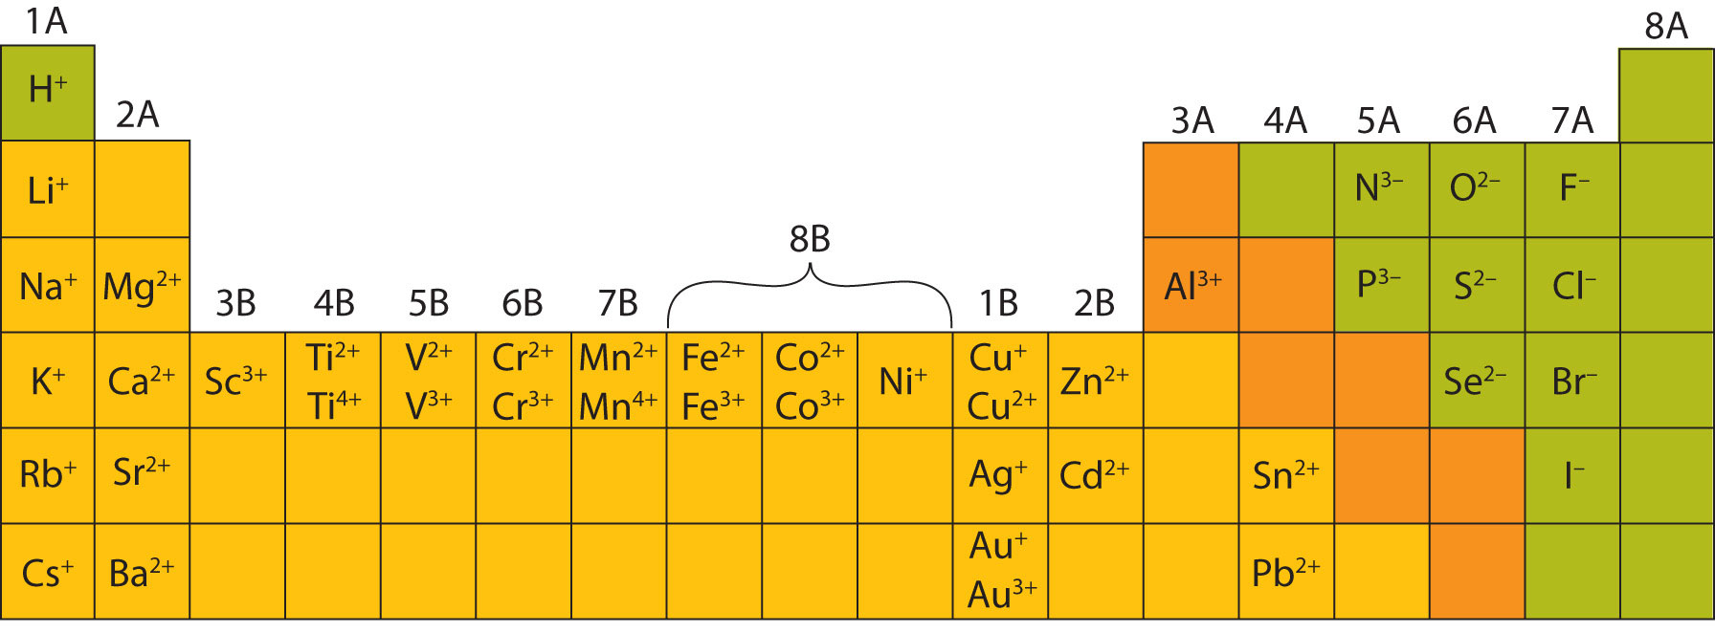

- What do you notice about most of the transition metals in the diagram above? Why do you think this occurs?

The relationship between electron configurations of transition metals and their ions is complex. They can lose different numbers of electrons to form cations with different charges.

Example: Cobalt
Neutral Atom: [Ar]4s²3d⁷ Co²⁺: [Ar]3d⁷ Co³⁺: [Ar]3d⁶

- What do you notice about the example above?

Transition metals will often lose their s electrons before losing their d electrons, even though the s orbital has less energy.
- Determine the electron configuration for the neutral atoms below and their most common ions.
Ti |  |  | Fe
Ti²⁺ |  |  | Fe²⁺
Ti⁴⁺ |  |  | Fe³⁺

