Name ___________________________________________________ Date ____________________________________ Period ___________
CLASSWORK: Defining Ionic Compounds
Review:

1. Draw the Lewis dot structures for the neutral atom and the ion of:

a. K K
b. Al Al
c. Ca Ca
2. Draw the Lewis dot structures for neutral atom and the ion of:

a. O O
b. Cl Cl
c. N N
Stop and Jot.
3. What comes to mind when you hear the word “compound”? How is a compound different from an element or a mixture?

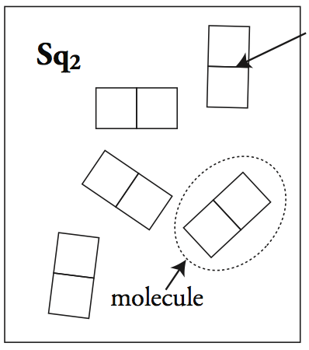
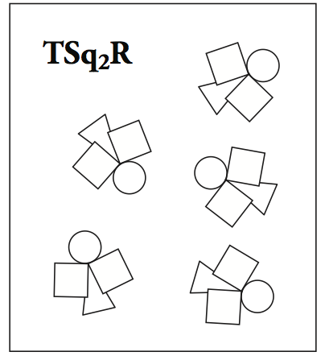
4. Review. Label the following pictures as an element, compound, or mixture:
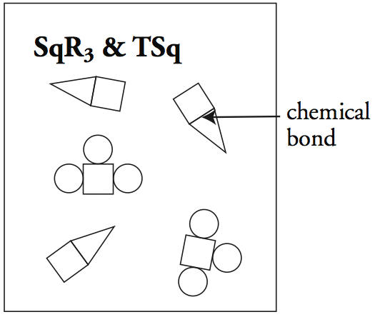
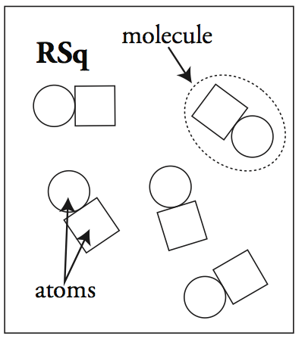
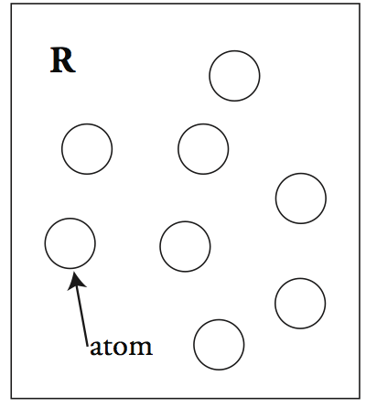
A. ________________ B. _________________ C. _________________ D. _________________ E. _________________

A compound is _______________________________________________________________________________________________________.
Three types of compounds: __________________________________, ____________________________, and _____________________.
Ionic Compound
Word Parts:

An ____________________ is _____________________________________________________________________________________________.
An ionic compound is formed when ______________________________________________________________________________.
Lewis Dot Structure | Bohr Model
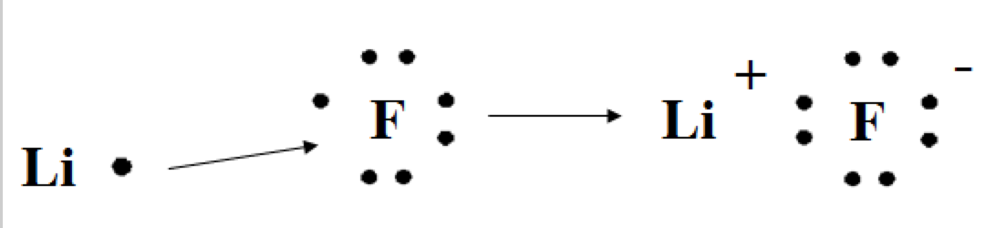
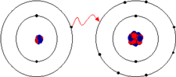
Example: Lithium Fluoride
All ionic compounds are composed of a _____________________________ and a ___________________________________.
Ionic compounds are always __________________________________________, meaning their charges __________________.
Example:

Practice.
- Write ionic or not ionic to identify if the following are ionic compounds or not. If yes, write the charges above each atom in the ionic compound.

  - ____________________________ CO
  - ____________________________NaBr
  - ____________________________ CaCl₂
Properties of Ionic Compounds | How we test for this property
1.
2.
3.
4.
  - ____________________________ Li₂O
  - ____________________________ MgO
  - ____________________________Al₂O₃
  - ____________________________PN
  - ____________________________OF₂

- An unknown substance is discovered. The substance has a very high melting point and is solid but breaks apart easily. The substance does not conduct an electric current when dissolved in water. Can you say with certainty that this new compound is an ionic compound? Explain your answer.

- Challenge. Write in charges above each atom and then determine if the following ionic compounds are electrically neutral. If not write in subscripts to change the number of atoms to balance the charges.

- K__Br___
- Na__O___
- Mg___Cl___
- Al___N____
- Al___F___
- Li___N___
- Ca___Cl___
- Ca___Br____
- Mg___P____
- Ga____O___

