**DO NOT WRITE ON THIS SHEET!!!**

**CLASSWORK: Intermolecular Forces**

**WRITE ALL ANSWERS IN YOUR NOTEBOOK USING COMPLETE SENTENCES.**

**Part 1: Card Sort**

With your group, take the cards out of the bag and sort them into 4 different categories: dispersion, dipole-dipole, hydrogen, and ionic. Use your notes on PAGE 117 to help you sort them correctly. Once sorted, write the bond into the correct column of the table.

|  |  |  |  |
| --- | --- | --- | --- |
| **Dispersion** | **Dipole-Dipole** | **Hydrogen** | **Ionic** |
|  |  |  |  |

1. Based on what you’ve learned, which group of forces would evaporate the most quickly?
2. Which group would evaporate next?
   1. Now, based on electronegativity difference, place this group in order of evaporation from quickest to slowest to evaporate within this group. Explain your order.
3. Which group would evaporate after the group you named in #2?
   1. Now, based on electronegativity difference, place this group in order of evaporation from quickest to slowest to evaporate within this group. Explain your order.
4. Which group has the strongest intermolecular forces?
   1. Now based on electronegativity difference, which one in this group would **melt** first? Explain.

**Part 2: Critical Thinking**

1. Fill in the table below.

|  |  |
| --- | --- |
| Intermolecular Forces Present in Distilled Water | Intermolecular Forces Present in Salt Water |
|  |  |

1. Based on the table above and what you now know about intermolecular forces, which would take longer to boil? Explain using intermolecular forced vocab.

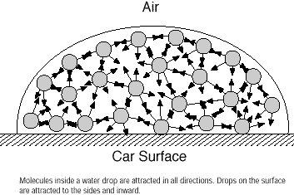

1. Examine the picture to the right with your group. Discuss what is happening between the water molecules when a drop of water forms. Think about the intermolecular forces. Write down what you discuss.

Surface of Penny

1. Discuss the intermolecular forces present in each of the compounds shown below. Based on what you observe, which substance do you think would be able to hold the most drops on a penny’s surface? List the five substances from fewest drops, to most drops. Explain your answer.

