Name __________________________________________________ Date ______________________________ Period ______________
STATION 1: Significant Figures
When we record data from a lab, it is very important that the data is reported with the correct number of significant figures. The more significant figures, the more precise the measuring instrument. All significant figures include ALL digits of certainty plus one uncertain digit. Consider the ruler below:
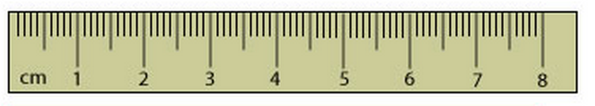
***String:

How many significant figures can be recorded from this instrument? Let’s measure the string above on the instrument. It can certainly be said that the string is 5.4 centimeters. However, the hundredths place is uncertain. Therefore, one digit of uncertainty MUST be estimated using this ruler. 5.40cm, 5.41cm, or 5.42cm for example, are all acceptable measurements of this string. This particular ruler can measure 3 significant figures. Two digits (the ones and the tenths place) are certain and one digit (the hundredths place) is uncertain.

Underneath each picture write how many significant figures could be recorded using each instrument:
Data | # of Sig Figs | How many digits of certainty? | How many digits of uncertainty? | Which Instrument from above could the data have come from?
24 mL | 2 | 1 | 1 | B. Beaker
24.0 mL
24.00 mL
18.5 mL
18.50 mL
18.25 mL
18.2 mL
18.0 mL
18 mL
A. Graduated Cylinder B. Beaker C. Buret
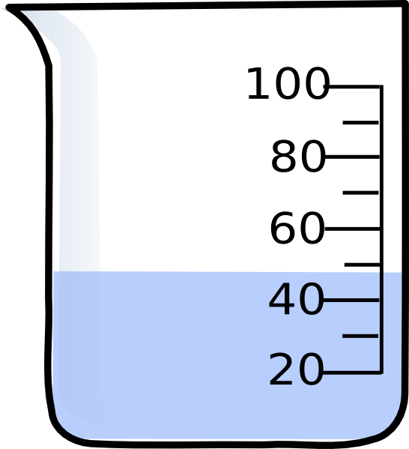
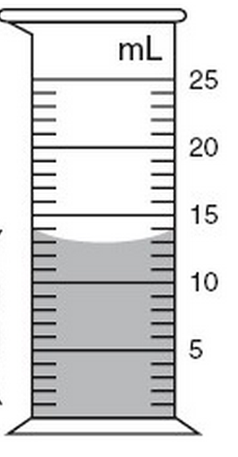
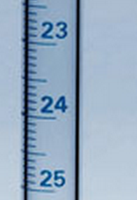

__________________ ____________________ ____________________
Rules for counting significant figures:
- All nonzeros are significant (1 – 9)
- All zeros sandwiched between nonzeros are significant.
- If there is a decimal, all zeros AFTER A NONZERO are significant.
1. Counting.
How many significant figures are in:

- 11,000,000 = ________________________
- 11,000,000. = ________________________
- 11,000,000.00 = ________________________
- 0.0000011 = ________________________
- 0.000001100 = ________________________
- 2,002,000 = ________________________
- 2,002 = ________________________
- 2,002,000.00 = ________________________
- 0.00000008 = ________________________
- 3.00x10²³ = ________________________
- 2.1x10⁻⁵ = ________________________
- 9.9900x10³³ = ________________________

2. Rounding.

Round the following numbers to 2 significant figures:
- 2,552 = ________________________
- 0.2552 = ________________________
- 0.002552 = ________________________
- 3,211 = ________________________
- 339,378,999 = ________________________
- 0.088888 = ________________________
Round the following numbers to 3 significant figures:
- 2,578 = ________________________
- 0.2578 = ________________________
- 0.002578 = ________________________
- 3,211 = ________________________
- 339,378,999 = ________________________
- 0.088888 = ________________________

***READ THIS: When performing calculations with multiplication or division, it is important that your answer is recorded with the correct number of significant figures. Whichever number has the LEAST amount of significant figures will determine how many significant figures should be in your final answer.

3. Calculate.
Solve the following calculations. Then record your answer with the correct number of significant figures.

- 7.25 x 0.33 = ____________________________________
- 0.75 ÷ 0.222 = ____________________________________
- 2,000 x 123 = ____________________________________
- 0.002 x 1,780 = ____________________________________
- 93.1 x 0.899 = ____________________________________
- 50 ÷ 23 = ____________________________________
- 0.79 x 0.20 = ____________________________________
- 801 ÷ 23 = ____________________________________
- 1.20 ÷ 0.300 = ____________________________________
- 2.000 x 54.2= ____________________________________
- 0.0300 x 34.1= ____________________________________
- 0.05 ÷ 0.85 = ____________________________________
- 3.45 ÷ 2.10 = ____________________________________
- 1,010 x 0.24 = ____________________________________
Application.

4. How many moles are in 6.89 x 10²⁵ atoms of silver?

5. How many atoms are in 0.25 moles of aluminum?

6. How many atoms are in 23.7 g of strontium?

7. What is the mass, in grams, of 4.9 moles of arsenic?

