Name: __________________ Date:_______________ Period: ______
REVIEW STATION 4: Structure of an Atom/ Periodic Table

Label the pictures below and complete statements to the right.
The atomic number represents the number of _________________ or ________________________ in an atom.

The atomic mass equals the number of ____________________ + __________________ in an atom.
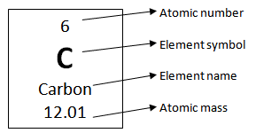

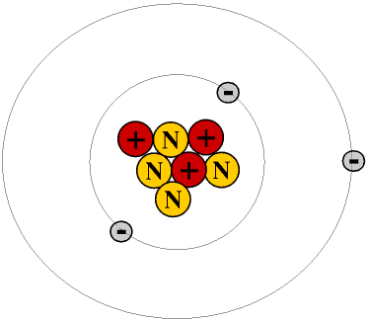
Neutrons are subatomic particles with a ______________________ charge found in the ______________________ of an atom.

___________________ are subatomic particles with a negative charge found in the _________________________ of an atom.

__________________ are subatomic particles with a ________________ charge found in the nucleus of an atom?

What is the name of the atom represented by the Bohr model to the left?

Fill in the missing information in the boxes below using your periodic table.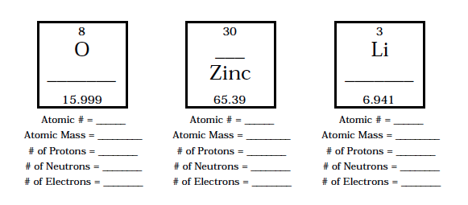

For each of the following isotopes, write the number of protons, neutrons, and electrons.
 | Carbon-12 | Carbon-16
# of protons
# of neutrons
# of electrons

 | Chromium-58 | Chromium-63
# of protons
# of neutrons
# of electrons

 | Nitrogen-15 | Nitrogen-20
# of protons
# of neutrons
# of electrons

 | Sulfur-23 | Sulfur-25
# of protons
# of neutrons
# of electrons

Color the periodic table and the key included below based on these instructions. Check the box once complete.
- Shade in the alkali metals with the color red. BE CAREFUL ABOUT HYDROGEN!!!!!!!
- Shade in the alkaline earth metals with the color yellow.
- Shade in the transition metals with the color green.
- Shade in the halogens with the color blue.
- Shade in the Noble Gases with the color orange.
- Shade in the metalloids with the color light blue.
- Shade in the other non-metals with the color pink.

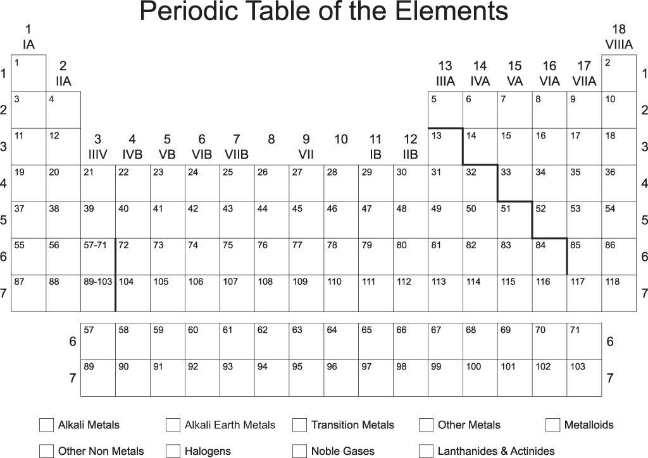

Name a halogen: ____________________________

Name a metalloid: ___________________________

Name an alkali metal: ________________________
Name an alkaline earth metal: __________________

Name a noble gas: ___________________________

Name a transition metal: ____________________________

