Name ______________________________________________________ Date _________________________________ Period __________
STATION REVIEW: Mole Calculations
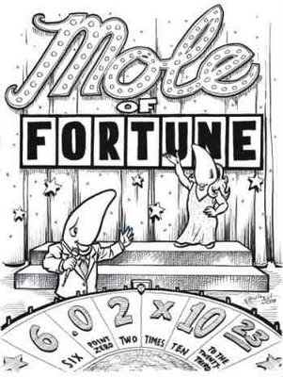
Atoms are too small to see so we cannot count them by conventional methods. However, knowing how many atoms are present at the start of a reaction is crucial to understanding how much product can be produced through chemical means. Therefore, to count atoms we will use their relative mass on the periodic table to calculate the number of atoms present.

Don’t forget:
1 mole = 6.022x10²³ items which in standard notation is 602,200,000,000,000,000,000,000 items. That’s a lot of items! To put this in perspective, if you had 1 mole of dollars, you could spend a billion dollars a second for OVER 19 million years before running out of money!

Calculations:
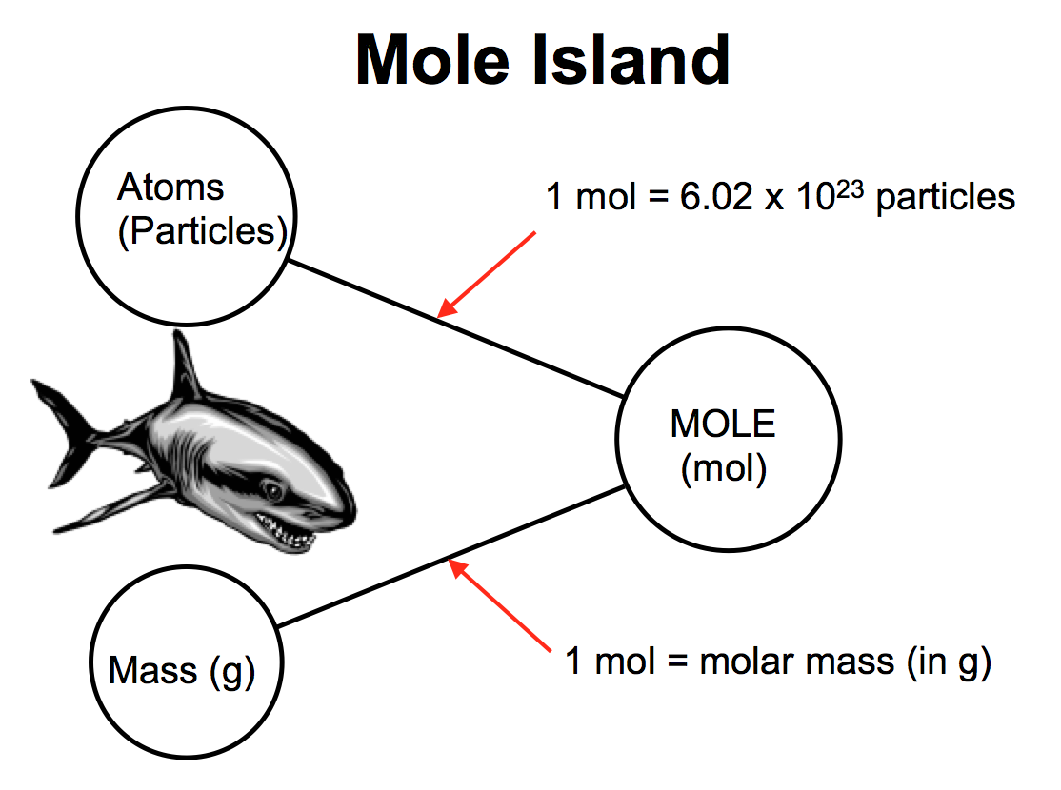
Use “Mole Island” to help you navigate problems.
Example 1: How many moles are in 3.4x10²⁴ atoms of sodium?

3.4x10²⁴ atoms 1 mole

6.022x10²³ atoms

=5.6 mol

Example 2: How many atoms are in 52.1 grams of calcium?
52.1 grams 1 mol 6.022x10²³ atoms

40.08 grams 1 mol

=7.83 atoms
*Solve the following problems. Then fill in the letter of the correct answer on the riddle on the bottom of page 2. Underline your given and circle your desired before solving.
- How many atoms of lithium are in .0211 moles of lithium metal (Li)

m. 1.27 x 10²³ atoms n. 1.27 x 10²² atoms o. 6.35 x 10²³ atoms p. 6.35 x 10²² atoms
2) How many moles of neon are in 4.3 x 10²⁴ atoms of neon (Ne)?

m. 71 mol n. 0.71 mol o. 7.1 mol p. 2.6 x 10⁴⁸ mol
3) How many moles of sodium chloride are in 3.28 x 10²³ formula units of sodium chloride (NaCl)?
*Hint: Think of a formula unit as a particle.

q. 1.98 x 10⁴⁷ mol r. 0.0545 mol s. 5.45 mol t. 0.545 mol
4) How many carbon monoxide (CO) molecules are present in 1.55 moles of CO?

m. 0.0933 molecules n. 0.933 molecules o. 24.8 molecules p. 9.33 molecules
5) What is the mass of 3.72 moles of silver atoms?

u. 401g v. 40.1 g w. 0.0344g x. 0.344g
6) How many moles of mercury are in 1,026 grams of mercury?

q. 511.5 mol r. 6.179 x 10²⁶ mol s. 205,800 mol t. 5.115 mol
7) How many atoms are in 80.2 grams of magnesium?

h. 4.00 atoms i. 1.99 x 10²⁴ atoms j. 1.99 x 10²² atoms k. 4.00 x 10²⁴ atoms
8) What is the mass, in grams, of 7.65 x 10²³ atoms of sulfur?

q. 0.407g r. 1.27g s. 0.127g t. 40.7g
9) How many moles are in 99.5g of carbon?

a. 5.99 x 10²⁵ mol b. 0.0828 mol c. 1.00 mol d. 8.28 mol
10) What is the mass, in grams, of 4.88 x 10²⁴ atoms of beryllium?

m. 52.1g n. 8.01 g o. 73.0 g p. 9.01g
11) How many cesium atoms are in 0.015moles of cesium?

u. 132.91 atoms v. 2.0 atoms w. 9.0 x 10²¹ atoms x. 9.0 x 10²³ atoms
12. What is the mass of 0.0033 moles of gold?

m. 196.97g n. 0.65 g o. 65g p. 2.0 x 10²¹g
Have you heard about the chemist reading about that book on helium? He just could

_____ _____ _____ _____ _____ _____ _____ _____ _____ _____ _____ _____!

