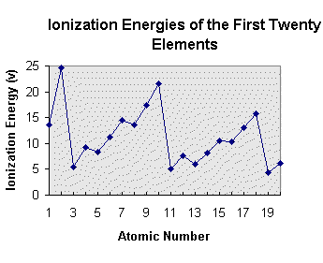

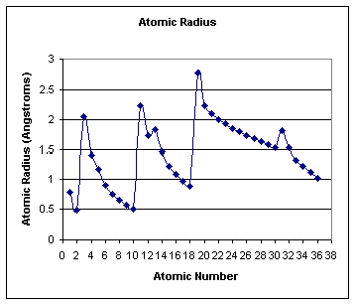

Station 9: Trends and Graphing Review
Task 1: Describe the trends for ionization energy, atomic radius, electronegativity.

Task 2: Review of annotation of the graphs, you can also reference back in your notebook the sections that relate to periodic trends:
- Select the graph for ionization energy or atomic radius
- Annotate the graph
  - Identify the element by their atomic number and list them on the graph
  - Put a box around the elements of the same period
  - Find the elements of the same group, label or identify
- Write the trend with regards to group and period
- Answer the questions from task 3.
- Repeat steps 1-4 for the other trend.
Task 3: With your partners take turns asking and answering the following questions with each other.

Atomic radius
- What is the element with the largest atomic radius in group 2A?
- Identify the atomic radius of sodium, hydrogen and chlorine
- Which group has the smallest atomic radius in a given period? Why?
- If the trend continued what would you expect the next period to look like include atomic numbers in your answer
Ionization energy
- Which element would have the highest ionization energy in group 2A
- Identify the ionization energy sodium, hydrogen and neon.
- Which group would have the smallest ionization energy in a given period? Why?
- If the trend would continue for elements 21-36 what would you expect the graph to look like? Include which elements you would expect to have the highest and lowest values.

Answer Key
Task 1:
Ionization energy increases right across a period and up a group.
Atomic radius increases down a group and decreases across a period (gets smaller).
Electronegativity increase up a group and across a period, except for noble gases (group 7A) which do not have an electronegativity due to their complete octet.
Task 3:
Atomic radius
- Radium as you move down a group the radius gets larger
- 2.25 angstroms = sodium, 0.75 angstroms= hydrogen and 0.95 angstroms= chlorine
- The element in group 1A because it is the first in the period
- An increase for rubidium above 2.75 angstroms then a decrease in the atomic radius as you move across the period ending the smallest element in group 8A (xeon)
Ionization energy
- Beryllium as you move down a group the ionization energy gets smaller so the largest would be at the top.
- 5 volts for sodium, 14 volts for hydrogen and 13 volts for chlorine
- The element in group 8A because the ionization energy increases across a period.
- The lowest point would be potassium which would be around 3 volts while krypton would be the highest around 15 volts. The amounts would steadily increase across the period from 3 volts to 15 volts.

