Name ___________________________________________ Date _____________________ Period _________
AGENDA: Semester 2 Exam Review

Date | Topic | Homework
 |  | PA | Honors
M – Jun 8 | Peer Review of Paper | Questions 1-8 | Questions 1-10
T – Jun 9 | Work on Final Draft of Paper | Questions 9-16 | Questions 11-20
W – Jun 10 | Complete Final Draft of Paper | Finish Final Draft Capstone Paper
Th – Jun 11 | Chemistry Capstone Paper DUE!!! | Questions 17-24 | Questions 21-27
F – Jun 12 | Review for Semester 2 Final Exam | Questions 25-34 | Questions 28-38
M – Jun 15 | Review for Semester 2 Final Exam | Study for Final Exams | STUDY
T – Jun 16 | 2nd, 5th, and 7th Period Final Exams | Study for Final Exams | STUDY
W – Jun 17 | 4th, 6th, and 8th Period Final Exams | Study for Final Exams | STUDY
Th – Jun 18 | 1st and 3rd Period Final Exams | No Homework
F – Jun 19 | LAST DAY OF SCHOOL | Have a fun & safe summer break!!!
Unit 5: Covalent Bonding
- Fill in the following blanks:
  - Covalent bonds form when electrons are _________________ between ___________________.
  - Ionic bonds form when electrons are ___________________ between ____________________.
- Write the chemical name for the chemical formulas listed below:

  - PBr₃ _________________________
  - Na₂O _________________________
  - SCl₄ _________________________
  - N₂F₂ _________________________
  - SO₃ __________________________
  - Mg(OH)₂ ______________________
  - NaOH ________________________
  - CO₂ __________________________
  - C₂H₄ __________________________
  - AlPO₄ _________________________
  - KNO₃ __________________________
  - P₅O₁₀ __________________________
- Write the chemical formula for the following chemical names:

  - Carbon trioxide ________________
  - Potassium Chloride _____________
  - Calcium Chloride _______________
  - Iron (III) Bromide ______________
  - Trinitrogen Heptoxide _____________
  - Sulfur Hexafluoride _______________
  - Copper (I) Iodide ________________
  - Tetraphosphorus Nonasulfide _______
- Determine if the following pairs of elements would form an ionic bond, a covalent bond, or neither.

  - Na and O ___________________
  - C and H ____________________
  - H and Cl ___________________
  - O and He __________________
  - F and Br ___________________
  - Ne and He __________________
  - H and Li ___________________
  - H and He __________________

- What is the total number of electron pairs shared in a molecule of:

  - H₂

  - O₂

  - F₂
  - P₂

  - S₂

  - N₂

Unit 5: Intermolecular Forces
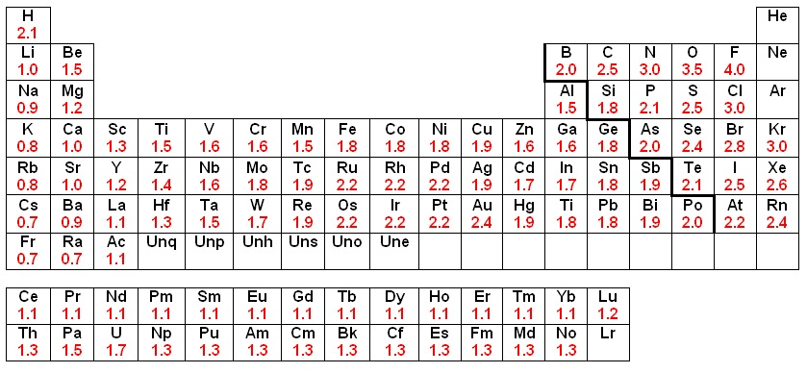
Use the table above to answer questions 7-8.
- Determine if the following compounds are ionic, polar covalent, or nonpolar covalent.
- LiF | - PO
- SSe | - MgS
- N₂ | - AlN
- BrI | - NI
Electronegativity Difference | Type of Bond
0.0-0.4 | Nonpolar Covalent
0.5-1.9 | Polar Covalent
≥1.5 | Ionic
- Rank the following compounds from most polar to least polar.
  - OH
  - OCl
  - OF
  - OBr

- Define a nonpolar covalent molecule:

- Define a polar covalent molecule:

- Matching. Match the definition with the correct intermolecular force.
_____ a. Hydrogen Bonding | i. An attractive force that occurs between two nonpolar covalent molecules.
_____ b. Dispersion Forces  (*also known as London Dispersion Forces  or LDF) | ii. An attractive force that occurs between two ionic compounds.
_____ c. Ionic Forces | iii. An attractive force that occurs between a hydrogen atom in one molecule and either an oxygen, fluorine, or nitrogen atom in another molecule.
_____ d. Dipole-Dipole | iv. An attractive force that occurs between two polar covalent compounds.
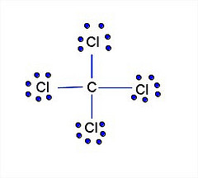
- Label each covalent compound as either nonpolar covalent or polar covalent:

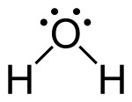

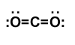

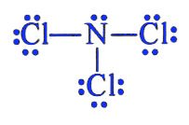

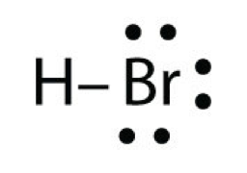

- What type of intermolecular forces will water experience? Draw two water molecules to show the interactions.

Unit 6A: Chemical Bonding
- Label the products, reactants, coefficient, and subscript in the chemical reaction below:

Zn + 2 NaCl → ZnCl₂ + 2 Na

- In a particular chemical reaction, the total number of atoms for the reactants are as follows: 6 Carbon atoms, 12, oxygen atoms, and 16 hydrogen atoms. How many of each atom, carbon, hydrogen, and oxygen, should be present in the products of the reaction? How do you know?

- Balance the following chemical equations:
a. ___ H₂ + ___ O₂ ____H₂O b. ___ Al₂O₃ ___ Al + ___ O₂

c. ___ C₃H₁₈ + ___ O₂ ___ CO₂ + ___H₂O d. __Fe₂(SO₄)₃ + __KOH __K₂SO₄ + __Fe(OH)₃

e. ____NaOH + ___ H₂SO₄ ____Na₂SO₄ + ____H₂O f. __Ca₃(PO₄)₂ + ___SiO₂ ___P₄O₁₀ + ___CaSiO₃

- Fill in the table below with the correct reaction or general form of a reaction.
Reaction Type | General Form | Example Reaction
 | A + B AB
 |  | CaCO₃ CaO + CO₂
Single Replacement

 | AB + CD AD + CB
 |  | C₃H₆O + 4 O₂ 3 CO₂ + 3 H₂O

- Predict the products of the following reactions and balance the equations.
a.) Type of Chemical Rxn: | b.) Type of Chemical Rxn:
_____AlCl₃ | _____NO₂
c.) Type of Chemical Rxn: | d.) Type of Chemical Rxn:
_____Rb + ______CaCl₂ | _____Al + _____Na₂SO₃
e.) Type of Chemical Rxn: | f.) Type of Chemical Rxn:
______Li + _____O₂ | ______C₂H₄ + ______O₂
g.) Type of Chemical Rxn: | h.) Type of Chemical Rxn:
_____PbBr₂ + ______HCl | ______K + ______Mg₃(PO₄)₂
- = carbon = oxygen = hydrogen

  - What is the correct formula for:

  - What is the correct formula for:

  - What is the correct formula for:

  - Draw the best depiction for 2CO₃.

  - Draw the best depiction for 3CH₄

  - Draw the best depiction for 4H₃O.

- Draw the Lewis Dot structure for the following compounds. THEN determine if the structure is polar or nonpolar based on your drawing.

  - CCl₄

  - CO

  - Dinitrogen monoxide

  - Sulfur trioxide

  - PH₃

  - Ozone (O₃)

- For each of the following reactions, A. Predict the products of the reaction, including their states of matter (use your solubility rules!). B. Write the total ionic equation, including the charges. C. Write the net ionic equation.
  - __AgNO₃(aq) + ___KCl(aq) →
Total Ionic: ___________________________________________________________________________________________
Net Ionic: ___________________________________________________________________________________________

  - ___Mg(NO₃)₂(aq) + ___Na₂CO₃(aq) →
Total Ionic: ___________________________________________________________________________________________
Net Ionic: ___________________________________________________________________________________________

  - ___K₃PO₄(aq) + ___Al(NO₃)₃(aq) →
Total Ionic: ___________________________________________________________________________________________
Net Ionic: ___________________________________________________________________________________________

- Use the following reaction:
Na + Cl₂ NaCl
  - Use your rules to assign oxidation numbers to each atom
  - Which substance is oxidized? _________ c. Which substance is reduced? _________
- Write the oxidation half reaction: e. Write the reduction half reaction:

- Write the balanced redox reaction:

- Use the following reaction:
MgCl₂ + Al AlCl₃ + Mg
- Use your rules to assign oxidation numbers to each atom
- Which substance is oxidized? _________ c. Which substance is reduced? _________
d. Write the oxidation half reaction: e. Write the reduction half reaction:

f. Write the balanced redox reaction:

Unit 6B: Stoichiometry
- Calculate the molar mass of the following compounds:
a. sodium chloride ___________________ b. H₂O ___________________

c. dicarbon tetrahydride_______________ d. Li₂CO₃ _________________

e. Ca₃(PO₄)₂ _________________ f. aluminum nitrite __________

- Consider the chemical equation below when answering stoichiometry questions a-f.
4 NH₃ + 5O₂ 4NO + 6H₂O

  - How many moles of water will be produced if 2.7 moles of NH₃ are used up?

  - How many grams of NH₃ are used if 16.9 grams of NO are produced?

  - How many grams of H₂O are produced if 3.1 moles of NH₃ are used?

  - How many moles of oxygen gas are burned if 42.3 grams of NO are produced?

  - How many moles of oxygen gas will be burned if 165 moles of water are produced?

  - How many grams of H₂O are produced if 103.1 grams of O₂ are burned?

- If you are given 24.0 moles of C₃H₈ and 45.0 moles of O₂, what is the maximum moles of water that can be produced?
C₃H₈ ₊ 5O₂ 3CO₂ + 4H₂O

- If you are given 15.0 moles of Cu and 144.0 moles of HNO₃ what is the maximum moles of NO that can be produced?
3Cu + 8HNO₃ → 3Cu(NO₃)₂ + 2NO + 4H₂O

- Using the activity series found on the right determine if a reaction will occur. If a reaction will occur, predict the products.
  - Ca_{(s)} + Zn(NO₃)_{2(aq)}

  - Al_{(s)} + FeSO_{4(aq)}

  - Pb + Mg₃(PO₄)_{2(aq)}

Unit 7: Acids & Bases
- What are three characteristics of acids?

- What are three characteristics of bases?

- How does litmus paper respond to acids and bases?

- On the number lines below, show what color pH paper and phenolphthalein will turn for each pH unit.

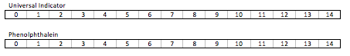
- Identify the acid, base, conjugate acid, and conjugate base in the equations below.
a. HCO₃– + H₂O H₂CO₃ + OH— b. HCl + NH₃ NH₄⁺ + Cl–

c. NH₃ + HCN NH₄⁺ + CN– d. H₂PO₄— + H₃O⁺ H₃PO₄ + H₂O

e. HBr + H₂O H₃O⁺ + Br— f. PO₄^{3—} + HNO₃ NO₃— + HPO₄^{2–}
EQUATIONS
Molarity = moles/liters
pH = -log [H₃O⁺]
[H₃O⁺] = 10^^{-pH}
M₁V₁ = M₂V₂
- Calculate the molarity of the solutions below:
  - 2.7 moles of lemonade are mixed in to 1.5 liters of water.

  - 0.058 grams of C₃H₈O₅ are mixed into 5 liters of water.

- Calculate the volume (liters) of the solutions below:
  - 14.5 moles of sodium chloride in a 2.5M solution.

  - 82.63g of KBr in a 5.00M solution.

- Calculate the pH based on the [H₃O⁺] listed below.

a. [H3O⁺] = 0.0027M, pH = ______________
b. [H3O⁺] = 2.6 x 10⁻⁷M, pH = ___________
c. [H3O⁺] = 8.1 x 10⁻³M, pH = ___________
d. [H3O⁺] = 1.1 x 10⁻⁹M, pH = ___________
e. [H3O⁺] = 0.00000094M, pH = __________
f. [H3O⁺] = 1 x 10⁻¹³M, pH = _____________
- Calculate the [H3O+] based on the pH values listed below.

a. pH = 13.8, [H3O⁺] = ________________
b. pH = 2.7, [H3O⁺] = ________________
c. pH = 5.5, [H3O⁺] = ________________
d. pH = 10.2, [H3O⁺] = ________________
e. pH = 4.8, [H3O⁺] = ________________
f. pH = 0.6, [H3O⁺] = ________________

- Calculate the concentrations of the dilutions described below.
a. How many mL of 0.7 M lemonade will be needed to make 120 mL of 0.2 M lemonade?

b. How many mL of 1.2 M lemonade will be needed to make 55 mL of 0.5 M lemonade?

- Calculate the concentrations of acids/bases in the titrations below.
a. What is the concentration of HCl if 12 mL were neutralized by adding 5 mL of 1.0 M NaOH?

b. What is the concentration of NaOH, if 110 mL were neutralized by adding 57 mL of 2.0 M NaOH

