CHEMISTRY READING #1: Reversing an Irreversible Reaction

STEP 1: Read and ANNOTATE the following article.

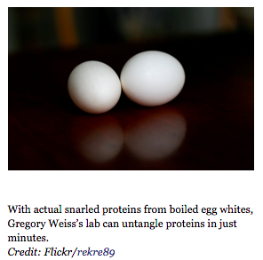
Unboiled Egg Untangles a Knotty Protein Problem
A new machine could help biotech with a faster, cheaper way to purify proteins
February 2, 2015 |By Sarah Lewin (Scientific American)

You can't unscramble an egg. But you can unboil it.
That's what chemist Gregory Weiss along other scientist at University of California, Irvine, and South Australia’s Flinders University managed to do, and their findings were published last week in the journal ChemBioChem. All it took was a chemical solution and a machine that spins at high speeds.
No, the study wasn't intended to figure out just how to unboil eggs. These aren't precious commodities. If you accidentally boil one, just grab another. Rather, the eggs were used as a substitute for a much more serious task: making cancer research more time and cost efficient.
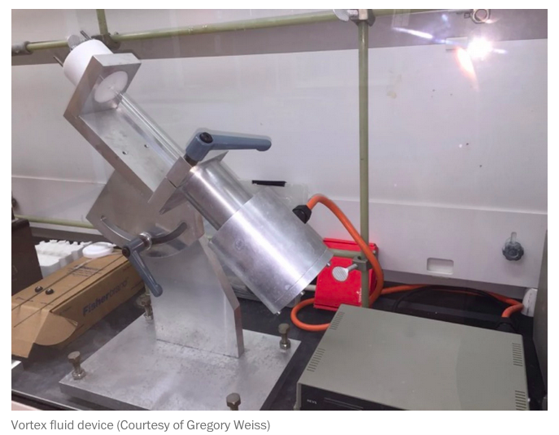
When scientists prepare a batch of proteins to study, such as antibodies that detect cancer, they lose some of the precious product in a tangled, gummy snarl. Unwinding those proteins and then letting them refold in their proper shapes is a tough, sometimes days-long process, and it usually saves only some of the material. It’s as hard as, say, unboiling an egg.
In their experiment, Weiss and his colleagues started with an egg white that had been boiled for 20 minutes at 194 degrees Fahrenheit (90 degrees Celsius), until its proteins became tangled clumps. Then they added a chemical that ate away at the egg white, effectively liquefying it. Next, they used a machine called a vortex fluid device to shape the egg white proteins back into their untangled form.

Refolding is the real challenge. Usually the solution is slowly pulled away and diluted bit by bit until the proteins can refold without crashing back together into a tangle. Other methods use heat or pressure to help the process along but they take a lot of energy and can damage the proteins.
The researchers now plan to build a larger-scale vortex machine and explore the different solutions, levels of force and settings that allow different proteins to refold, many of which are not currently cost-effective to purify.
Weiss anticipates that the vortex will catch the interest of many different disciplines. After all, proteins are used as medicine, research tools and industrial catalysts. “If we have ways of accelerating the production of proteins—making it easier, making it faster, requiring less water—all those things will have the effect of dropping the costs,” he says. Making this happen will take longer than boiling an egg but a lot of manufacturers and scientists will be watching closely.

STEP 2: SUMMARY
In one paragraph, write a summary of what this article discussed. Your summary should include the title, author, date and source of the article. This paragraph should also include who (name of scientist(s)), what (what they experimented), when (when was experiment done), where (where was experiment done) and why (why was experiment done) of the article.

STEP 3: REFLECTION
In a second paragraph, write a reflection focused on your thoughts and opinions on what you just read. Your reflection could (but does not have to) answer the following questions:
- What is your initial reaction to this article?
- What opinions do you have about what was discussed in this article? Do you agree or disagree with what was said in the article?
- What connection can you draw between this article and yourself or something else you have learned?
- What next steps could scientists take with what they have learned in this article?

