Name:___________________________________ Date:_____________ Period:_______________
UNIT 3: Test Review
Objective 1: SWBAT read the periodic table.
1. Which has more neutrons: Rubidium or Zinc?

2. Rank the following elements from largest to smallest atomic mass.
Element: Rank:
Magnesium _______
Potassium _______
Krypton _______
Copper _______
Indium _______

3. Ms. Ingham has identified an atom with an atomic mass of 48, 22 protons, 26 neutrons, and 22 electrons. She thinks it is iron, because iron’s atomic matches the number of neutrons she has found. Is she correct?

Objective 2: Students will be able to describe structure of the atom.

4. Label the diagram below with the particles name and charges.
Name:_____________________
Charge:___________________

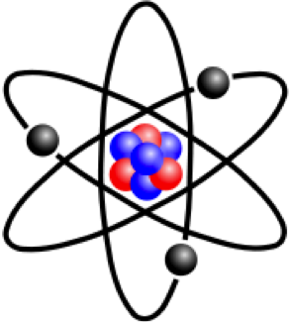

Name:_____________________
Charge:___________________

Name:_____________________
Charge:___Neutral________

5. If an atom is neutral, what does that tell us about the number of protons and electrons the atom has?

6. Which two particles contribute to an atom’s mass? Where are those particles found?

Objective 3: Students will be able to describe isotopes of an atom and calculate average
7. Why do isotopes form?

8. List the protons, neutrons, and electrons of each of the three isotopes of oxygen: ¹⁶O, ¹⁷O, and ¹⁸O.

9. Calculate the average atomic mass of an unknown element X that has two stable isotopes, ⁵⁰X and ⁸⁰X of equal abundance.

10. Iodine is 80% ¹²⁷I, 17% ¹²⁶I, and 3% ¹²⁸I. Calculate the average atomic mass of iodine.

11. All isotopes will have the same number of __________________________ and _______________________ but a

different number of ____________________________.

Objective 4: Differentiate between element, compound and mixture
11. What is an element? List three examples.

12. What is a compound? List three examples.

13. What is a mixture? List three examples.

14. What is the difference between a homogenous mixture and a heterogenous mixture?

Objective 5: Define energy levels in an atom and create Bohr models for common elements.
15. How many electrons are in the:
1st level of the Bohr Model:___________________________
2nd level of the Bohr Model:__________________________
3rd level of the Bohr Model:__________________________

16. Label the following Bohr Models:
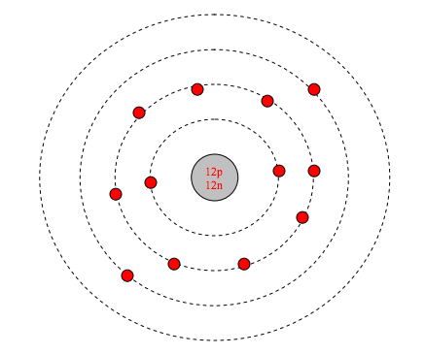
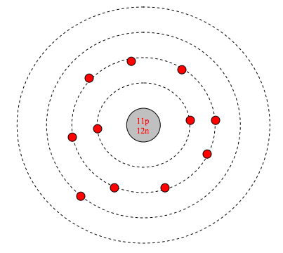

17. Draw the correct Bohr Models for the following atoms:

Neon Argon Oxygen Lithium

Objective 6: Students will be able to define valence electrons.
18. Fill in the table below with the correct number of electrons in each shell:
Shell | Number of Electrons
1
2
3
4

19. Fill in the table below with the correct number of valance electrons for each element:
Element | Valence Electrons
C
Se
Rb
Ne

20. Oxygen forms three stable isotopes of ¹⁶O, ¹⁷O, and ¹⁸O. Do all three isotopes have the same number of valance electrons? Explain.

21. If an atom has 57 electrons, how many are valance electrons? How do you know?

Objective 6: Students will be able to define an ion and explain the formation of positive and negative ions.
22. Ions from when an atom gains or loses __________________________________.

23. Fill in the table below with the appropriate charges of each atom:
Element | Change | Charge
Potassium | Lost 1 electron
Chlorine | Gained 1 electron
Copper | Lost 2 electrons
Sulfur | Gained 2 electrons
Calcium |  | +2
Lead |  | +2
Iron |  | +3
Oxygen |  | -2

24. Why do ions form?

Objective 6: Students will be able to convert among atoms, molar mass, and moles.

1. How many moles are in 3.5 grams of Tellerium?

2. How many atoms are in 4.7 moles of water?

3. How many atoms are in 17.2 grams of Iodine?

4. How many moles are in 6.5 x 10³² atoms of Strontium?

5. How many grams are in 7.7 x 10⁷⁷ atoms of NaCl?

6. How many grams are in 0.57 moles of MgS?

