Name ____________________________________________________________ Date _______________________ Period ________
CATALYST CHART: Week _____
Date + Homework | Objective | Answer and Explanation | Correct?
Mon. ________  Homework: |  | Standard:
Tues. ________  Homework: |  | Standard:
Wed. ________  Homework: |  | Standard:
Thurs. ________  Homework: |  | Standard:
Fri. ________
Homework:

Parents: Please feel free to email
(llingham@cps.edu) with any questions
or concerns. Thanks!
Guardian Signature:____________________________________________________

Graph 1
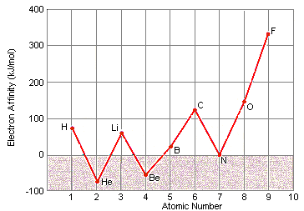

Graph 2
