Name ____________________________________ Date ________________ Period ________
WEEK 15 AGENDA: Unit 4 course website: kachemistry.weebly.com
Date | Topic | Homework
 |  | CB | H
M – Dec 8 | POGIL: Electron Configuration  Electron Configuration Notes | 1-3; 4a, 4b, 5-6 | 1-6
T – Dec 9 | Electron Configuration Practice | 7-11a-c | 7-13  Textbook Reading Due FRIDAY!!
W – Dec 10 | Columbic Attraction | 14-17 | 14-17
Th – Dec 11 | QUIZ  Periodic Trends: Atomic Radius | TBA | TBA  Reading Due Tomorrow
F – Dec 12 | Periodic Trends: Electronegativity | TBA | TBA
*To receive credit for your homework, your answers MUST BE WRITTEN IN YOUR NOTEBOOK!
- How did Mendeleev organize the first periodic table?
- Columns going up and down the periodic table are called _________________________.
- Rows going across the periodic table are called ________________________.
- Name at least 3 things each of the groups below have in common
  - Alkali Metals b. Alkaline Earth Metals
  - Halogen d. Noble Gases
- In an electron configuration, what does the sum of the superscripts equal?
- Fill in the following table. *You may write in this table!
Electron Configurations for Some Selected Elements
Element | Orbital Box | Electron Configuration
H | _____ _____ _____ _____ _____ _____  1s 2s 2p 3s | 1s¹
He | _____ _____ _____ _____ _____ _____  1s 2s 2p 3s
 | _____ _____ _____ _____ _____ _____  1s 2s 2p 3s | 1s²2s¹
C | _____ _____ _____ _____ _____ _____  1s 2s 2p 3s
 | _____ _____ _____ _____ _____ _____  1s 2s 2p 3s | 1s²2s²2p³
O | _____ _____ _____ _____ _____ _____  1s 2s 2p 3s
 | _____ _____ _____ _____ _____ _____  1s 2s 2p 3s | 1s²2s²2p⁶
_____ _____ _____ _____ _____ _____
1s 2s 2p 3s

- Label s-block, p-block, d-block, and f-block on the periodic table below. Color in each block a different color or use a different pattern to show each block.
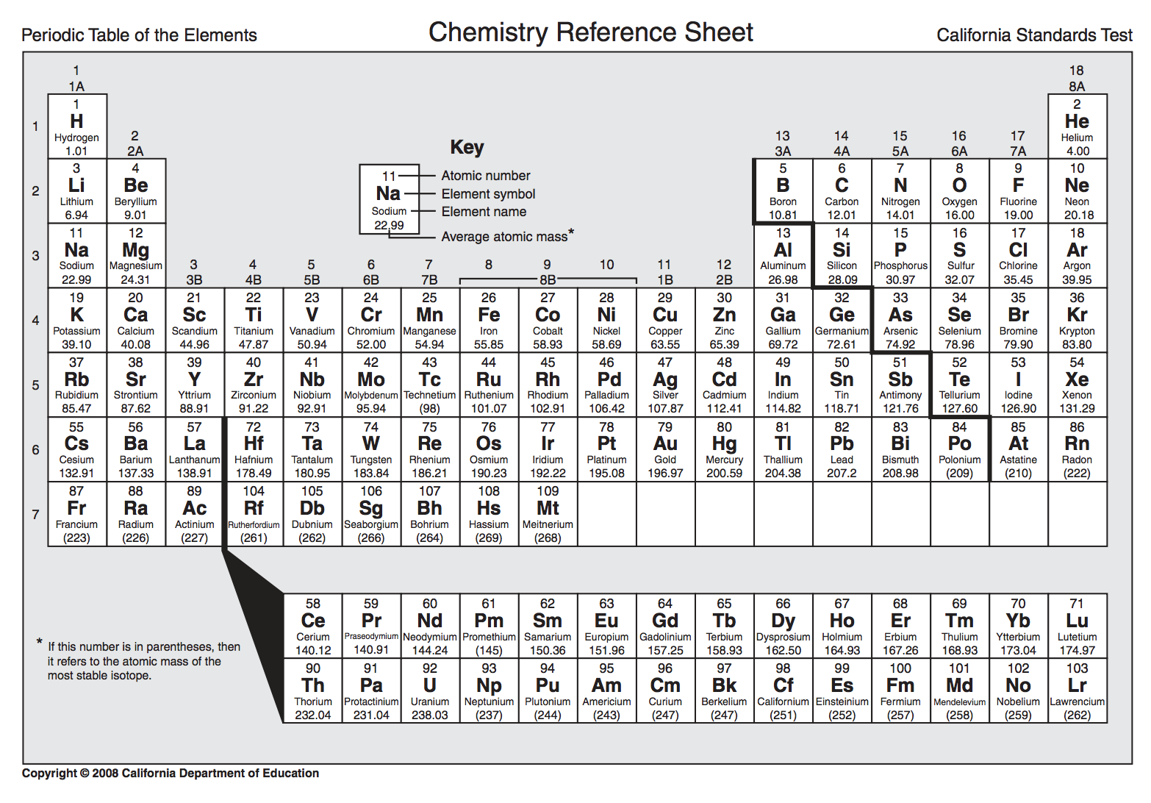

- Which atom ends in an electron configuration of 2p²?
- Which atom ends in an electron configuration of 3s²?
- What electron configuration should Alkali Earth metals end in?
- Write the electron configuration for each of the following atoms. (HONORS: write in long form and noble gas notation)
  - Beryllium
  - Phosphorus
  - Bromine
  - Silver
  - Uranium (CHALLENGE!)
- Why do some atoms NOT obey the Aufbau principle?
- Name two atoms that have electrons configurations that do not obey the Aufbau principle?
- What is Coulombic attraction?
- What is the relationship between the number of protons in the nucleus and attractive force?
- Compared to boron, in which of the following elements will attractive force be strongest: calcium, neon, or chlorine?
- Why, as Coulombic attraction increases, does atomic radii also increase?

