Name ____________________________________ Date ________________ Period ________
WEEK 22 AGENDA: Unit 5 (Covalent Compounds) course website: kachemistry.weebly.com
Date | Topic | Homework
 |  | PA | H
M – Feb 9 | Drawing Lewis Dot Structures | Complete Class Work | Complete Class Work
T – Feb 10 | Molecular Geometry | Week 21 Agenda #11 | Week 21 Agenda #11
W – Feb 11 | Bond Polarity | 1a-e, 2-4 | 1c-g, 2-4
Th – Feb 12 | Intermolecular Forces | 5-9 | 5-9
F – Feb 13 | Intermolecular Forces Cont.
- Complete the table:
Formula | Lewis Dot Diagram | Bonds | Lone Pairs | Polarity (Polar or Nonpolar?) | Geometry
a) HCN
b) NO₂⁻
c) CH₄
d) NH₃

e) H₃O⁺
f) C₂H₄ |  | X | X | X | X
g) SO₃²⁻

Electronegativity values
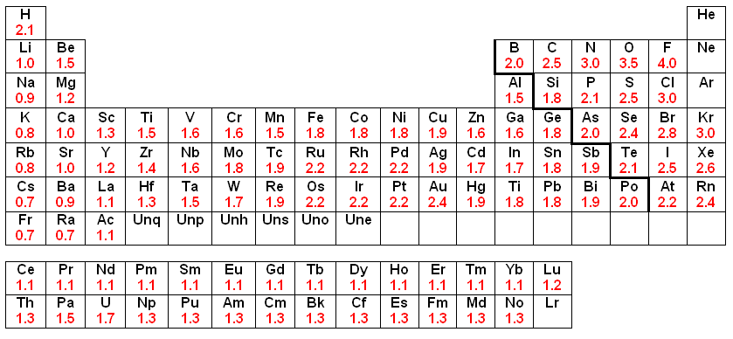

Bond Type | Difference in  electronegativities
Nonpolar | 0.0 – 0.4
Polar | 0.5 – 1.9
Ionic | > 1.5

Use the electronegativities in the periodic table above or on the back of your periodic table for the following questions:
- In your own words, what is electronegativity?
- Describe the following bonds in the following compounds as ionic, polar, or nonpolar. *If the covalent compound is polar: denote the partially positive side with δ+ and the partially negative side with δ-.
  - HBr d. H₂O g. CO
  - NaBr e. HI h. H₂
  - Br₂ f. CaO i. MgS
- The bonds between the following pairs of elements are covalent. Arrange them according to polarity, listing the most polar bond first.
  - Cl—Cl d. Cl—O
  - Cl—C e. Cl—H
  - Cl—F
- What is a hydrogen bond?
- What causes dispersion forces?
- Rank the following intermolecular forces from weakest to strongest: dipole-dipole, ionic forces, dispersion forces, hydrogen bonds.
- Rank the following intramolecular forces from weakest to strongest: ionic bonds, polar covalent bonds, nonpolar covalent bonds.
Compound | Ionic or Covalent | Name
Li₂O
 |  | Dinitrogen tetroxide
FeCO₃
 |  | Cobalt (II) sulfide
PH₃
 |  | Magnesium Bromide
P₄S₃
- Fill in the following table:

