Name ____________________________________ Date ________________ Period ________
WEEK 22 AGENDA: Unit 5 (Covalent Compounds) course website: kachemistry.weebly.com
Date | Topic | Homework
 |  | CB | PA | H
M – Feb 9 | Electronegativity and Bond Types | 1; 2a-f; 3-5 |  | 1-5
T – Feb 10 | Notes: Intermolecular Forces | 6-9 |  | 6-9
W – Feb 11 | Lab: Intermolecular Forces Day 1 | 10 |  | 10
Th – Feb 12 | Lab: Intermolecular Forces Day 2
F – Feb 13 | Intermolecular Forces Lab Write-Up Day | complete lab write up | complete lab write up | complete lab write up

1) Are electrons shared equally or unequally in a nonpolar bond? A polar bond?

2) Use the molecular geometry sheet to aid you in filling in the table below.
Formula | Lewis Dot Diagram | Bonds | Lone Pairs | Polarity (Polar or Nonpolar?) | Geometry
a) BeH₂
b) BH₃
c) HCN
d) NO₂
e) CH₄
f) NH₃
g) CO
h) PO₄³⁻
i) H₃O⁺

Electronegativity values
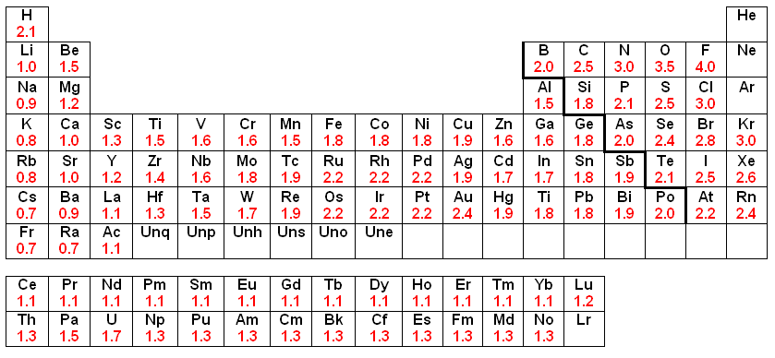

Bond Type | Difference in  electronegativities
Nonpolar | 0.0 – 0.4
Polar | 0.5 – 1.9
Ionic | > 1.9

Use the electronegativities in the periodic table above for the following questions:
- In your own words, what is electronegativity?
- Describe the following bonds in the following compounds as ionic, polar, or nonpolar. Then determine what type of intermolecular forces would present between each compound if there were many of the same molecules present. For example, H-Br is polar covalent so if there were many H-Br there would be dipole-dipole forces present. *If the covalent compound is polar: denote the partially positive side with δ+ and the partially negative side with δ-.
  - HBr d. H₂O g. CO
  - NaBr e. HI h. H₂
  - Br₂ f. CaO i. MgS
- The bonds between the following pairs of elements are covalent. Arrange them according to polarity, listing the most polar bond first.
  - Cl—Cl d. Cl—O
  - Cl—C e. Cl—H
  - Cl—F
- What is a hydrogen bond?
- What causes dispersion forces?
- Rank the following intermolecular forces from weakest to strongest: dipole-dipole, ionic forces, dispersion forces, hydrogen bonds.
- Rank the following intramolecular forces from weakest to strongest: ionic bonds, polar covalent bonds, nonpolar covalent bonds.
- Fill in the following table:
Compound | Ionic or Covalent | Name
Li₂O
 |  | Dinitrogen tetroxide
FeCO₃
 |  | Cobalt (II) sulfide
PH₃
 |  | Magnesium Bromide
P₄S₃

