Name ____________________________________ Date _________________________ Period _______
WEEK 27 AGENDA: Unit 6 (H) website: kachemistry.weebly.com

Date | Topic | Homework
 |  | Honors
M – Mar 16 | Net Ionic Equations | Finish WS from Class, #1
T – Mar 17 | Predicting Products Review | 8-16
W – Mar 18 | QUIZ, PLAN Review | 17-21
Th – Mar 19 | Redox Reactions | 22-25
F – Mar 20 | Redox Reactions Cont. | 26-27
*Complete the following problems on a separate sheet of paper in your chemistry notebook.

- For each reaction below, determine the states of matter of the products (use the table below), then write the total ionic and net ionic forms of the equation:
  - 2NaCl (aq) + Pb(NO₃)₂(aq) PbCl₂ (___) + 2NaNO₃ (____)
  - 2(NH₄)₃PO₄(aq) + 3Zn(NO₃)₂ Zn₃(PO₄)₂(______) + 6NH₄NO₃(_____)
  - BaBr₂(aq) + Na₂SO₄(aq) 2NaBr(_____) + BaSO₄(_______)

  - Na₂CO₃(aq) + FeCl₂(aq) FeCO₃ (_______) + 2NaCl(_______)
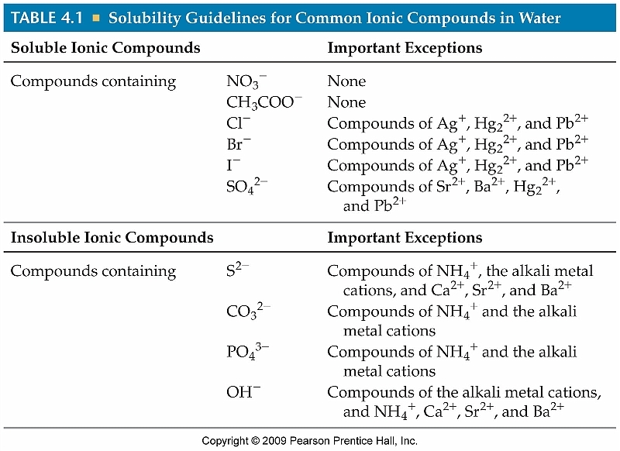

For questions 8-15, determine the type of reaction and complete and balance the equation. Be sure to include the states of matter for all products!! (Watch out for diatomics and check your charges in compounds!)

- C₃H_{8 (g)}+ O_{2 (g)}
- LiClO (aq) + KOH(aq)
- Ca(s) + O₂(g)
- BaCl₂(aq) + Na₂SO₄(aq)

- Cu_{(s)} + FeSO_{4(aq)}
- MgSO₄(aq) + Na₂CO₃(aq)
- Ba(OH)₂
- AgNO₃(aq) + KCl(aq)

- For the double replacement reactions in #8-15, write the total ionic and net ionic forms of the equations.

- Name three things that always stay the same in a chemical reaction.
- What changes in a chemical reaction?
- Define “reactant” and “product” in your own words.
- How many atoms of each type of element are present in the following compounds:
  - BeSO₄ e. Al(ClO₂)₃
  - 3BeSO₄ f. 5Ba₃(PO₄)₂
  - KClO₄ g. Li₂MnO₄
  - 7KClO₄ h. 6Li₂MnO₄
- Balancing Practice
  - ___NaClO₃ ___NaCl + ___O₂
  - ___(NH₄)₃PO₄ + ___Pb(NO₃)₄ ___Pb(PO₄)₄ + ___NH₄NO₃
  - ___C₅H₁₁ + ___O₂ ___CO₂ + ___H₂O

- What does it mean if a substance is oxidized in a reaction?
- What does it mean if a substance is reduced?
- Define oxidizing agent. Define reducing agent.
- Determine the oxidation number of each atom in the following substances:
  - NF₃ N F
  - K₂CO₃ K C O
c. NO₃⁻ N_________ O__________
- HIO₄ H I O
- Determine the oxidation number of each atom on the reactants and products side of the reactions below. Which element is being oxidized? Which is being reduced?
a. Mg + HCl MgCl₂ + H₂
b. Fe + V₂O₃ Fe₂O₃ + VO

- Use the following reaction:
Cu + HNO₃ CuNO₃ + H₂
  - Use your rules to assign oxidation numbers to each atom
  - Which substance is oxidized?
  - Which substance is reduced?
  - What is the oxidizing agent?
  - What is the reducing agent?
  - Write the oxidation half reaction.
  - Write the reduction half reaction.
  - Write the balanced redox reaction.

- Use the following reaction:
2H₂ + O₂ 2H₂O
  - Use your rules to assign oxidation numbers to each atom
  - Which substance is oxidized?
  - Which substance is reduced?
  - What is the oxidizing agent?
  - What is the reducing agent?
  - Write the oxidation half reaction.
  - Write the reduction half reaction.
  - Write the balanced redox reaction.

