Name ____________________________________ Date _________________________ Period _______
WEEK 27 AGENDA: Unit 6 website: kachemistry.weebly.com

Date | Topic | Homework
 |  | Pre-Accelerated
M – Mar 16 | Solubility Rules Lab | Post-Lab #1, #1-6
T – Mar 17 | Solubility Rules Cont. | Completed Solubility Lab Packet due tomorrow
W – Mar 18 | QUIZ, PLAN Review | 7-14
Th – Mar 19 | Reactivity Series Lab | 15-19
F – Mar 20 | Reactivity Series Cont. | 20-25
*Complete the following problems on a separate sheet of paper in your chemistry notebook.
1.) Type of Chemical Rxn: | 2.) Type of Chemical Rxn:
______C₁₀H₁₆(l) + ____O₂(g)  ☐Compounds: Charges Equal  ☐Elements: Diatomics? | _____Ca₃(PO₄)₂(aq) + _____SiO₂(aq)  ☐Compounds: Charges Equal  ☐Elements: Diatomics?
3.) Type of Chemical Rxn: | 4.) Type of Chemical Rxn:
______(NH₄)₂CO₃(aq) + _____ HCl  ☐Compounds: Charges Equal  ☐Elements: Diatomics? | _____Al(s) + ____HCl  ☐Compounds: Charges Equal  ☐Elements: Diatomics?
5.) Type of Chemical Rxn: | 6.) Type of Chemical Rxn:
___LiClO (aq) + ___KOH(aq)  ☐Compounds: Charges Equal  ☐Elements: Diatomics? | ___CuCl  ☐Compounds: Charges Equal  ☐Elements: Diatomics?

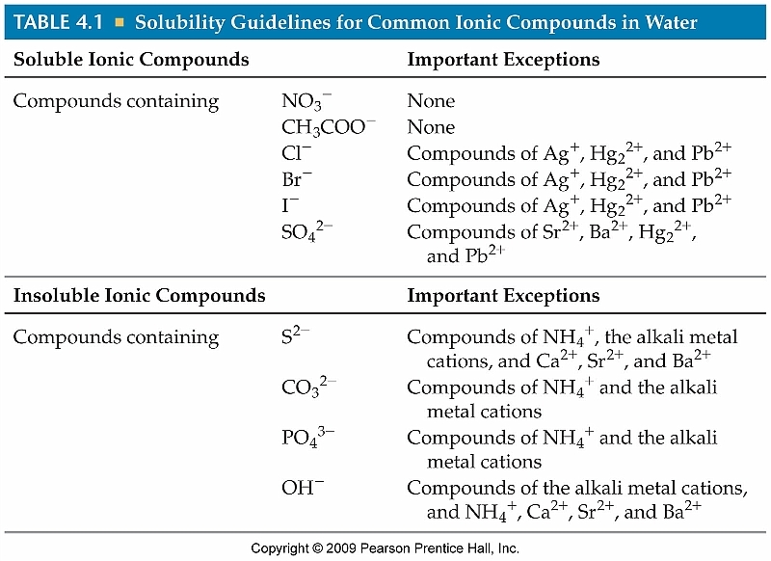
Write the balanced equation for the following reactions AND determine the state of matter for each product: (Use the table at right)

- Zn + CuSO₄ Cu + ZnSO₄
- Mg + AgNO₃ Ag + Mg(NO₃)₂
- Cl₂ + NaBr NaCl + Br₂
- CaO + H₂O Ca(OH)₂
- Ca(ClO₃)₂ CaCl₂ + O₂
- AgNO₃ + K₂SO₄ Ag₂SO₄ + KNO₃
- Zn(s) + CuBr₂(aq) ZnBr₂ + Cu
- C₈H₁₂ + O₂ CO₂ + H₂O

- Determine if each of the follow substances would be soluble (aq) or insoluble (s) in solution:
  - KBr
  - PbCO₃
  - BSO₃
  - zinc hydroxide
  - sodium acetate
  - silver iodide
  - cadmium (II) sulfide
  - zinc carbonate
- Name three things that always stay the same in a chemical reaction.
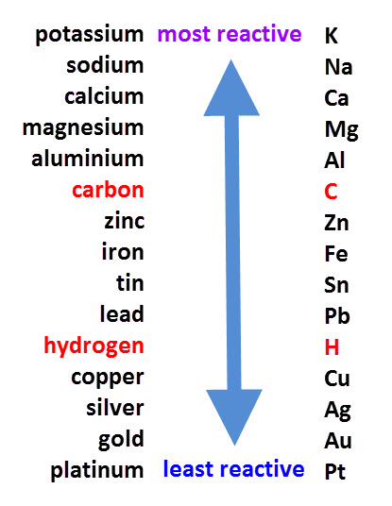
- What changes in a chemical reaction?
- Define “reactant” and “product” in your own words.
- How many atoms of each type of element are present in the following compounds:
  - BeSO₄ e. Al(ClO₂)₃
  - 3BeSO₄ f. 5Ba₃(PO₄)₂
  - KClO₄ g. Li₂MnO₄
  - 7KClO₄ h. 6Li₂MnO₄

- Balance the following: (SHOW ALL WORK!!)
  - ___CaCO₃ + ___H₃PO₄ ___Ca₃(PO₄)₂ + ___H₂CO₃
  - ___NaClO₃ ___NaCl + ___O₂
  - ___KOH + ___Co₃(PO₄)₂ ___K₃PO₄ + ___Co(OH)₂
- Based on the reactivity series diagram to the right, circle the more reactive metal:
  - Platinum or Zinc
  - Carbon or Hydrogen
  - Magnesium or Gold
  - Silver or Gold
  - Calcium or Zinc
- Explain why sodium can replace calcium in a compound but cannot replace potassium.
- Explain, in terms of reactivity, why most jewelry is made of silver, gold or platinum.
- Will the following reactions take place? (If Yes, write the new products and balance the equation)

  - Zn + Pb(NO₃)₂
  - Fe + ZnSO₄
  - Pb + Cu(NO₃)₂
  - Au + Pb(NO₃)₂
  - Mg + Ca(NO₃)₂
  - Ca + H₂O

