Name ____________________________________ Date ________________ Period ________
WEEK 9 AGENDA: Unit 2 course website: kachemistry.weebly.com
Date | Topic | Homework
 |  | CB | PA | H
M – Oct 27 | The Mole; Periodic Table Intro | 1; 2a-b; 3a-b; 4a-b | 1-3; 4a-c | 1-4
T – Oct 28 | Mole to Atom/Molecule Conversion | 5a-b; 6a-b | 5a-c; 6a-c | 5-6
W – Oct 29 | Mole to Grams Conversion | 7a-b; 8a-b | 7-8 | 7-8
Th – Oct 30 | Atom/Molecule to Mole Conversion | 9a-b; 10a-b | 9a-c;10a-c | 9-10
F – Oct 31 | Structure of the Atom; Skills Quiz | 11a-b;12a-b;13 | 11a-c;12a-c;13 | 11-13
*Complete the following problems on a separate sheet of paper in your chemistry notebook. SHOW ALL WORK TO RECEIVE FULL CREDIT! Remember for unit conversions you must show your work in a t-chart!

- What does each letter of the box represent?  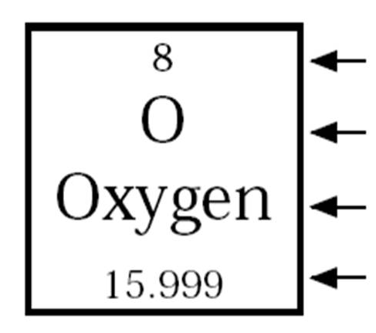  - Use your periodic table to determine the symbols for the following elements AND the number of protons, neutrons, and electrons:  - Gold  - Nitrogen  - Carbon  - Iron  - Use your periodic table to determine the names for the symbols below AND the number of protons, neutrons, and electrons:  - Silver  - Magnesium  - Sodium  - Calcium  - Use the T-Chart method to answer the following questions (show ALL work):  - How many donuts are in 6.5 dozen donuts?  - How many minutes are in 2 days?  - How many minutes are in 2.5 weeks?  - How many seconds are in 5 weeks?  - Calculate the number of atoms/molecules in the following quantities:  - 5.25 moles Aluminum  - 1.65 moles Carbon  - 2.55 x 10⁻¹⁵ moles Oxygen  - 0.0045 moles Calcium  - Calculate the number of moles in each of the following quantities:  - 6.022 x 10²⁴ atoms of cobalt  - 1.06 x 10²³ atoms of tungsten  - 3.008 x 10¹⁹ molecules of water  - 950000000 molecules of sugar | - Calculate the number of moles in each of the following masses:  - 0.039 g of palladium  - 8200 g of iron  - 0.0073 kg of tantalum  - Calculate the mass in grams of each of the following amounts:  - 1.002 mol of chromium  - 550 mol of aluminum  - 4.08 x 10⁸ mol of neon  - Calculate the number of atoms in each of the following masses:  - 54.0 g of aluminum  - 69.45 g of lanthanum  - 0.697 g of gallium  - 0.000000020 g beryllium  - Calculate the mass of the following numbers of atoms:  - 6.022 × 10²⁴ atoms of tantalum  - 3.01 × 10²¹ atoms of cobalt  - 1.506 × 10²⁴ atoms of argon  - 1.20 × 10²⁵ atoms of helium  - Determine the number of moles in each of the following:  - 3.00 g of boron (B)  - 0.472 g of sodium (Na)  - 7.50 × 10² g of methanol, CH₃OH  d. 50.0 g of aluminum chloride, Al₂O₃  12. Determine the mass of each of the following amounts:  - 1.366 mol of nitrogen (N)  - 0.120 mol of calcium (Ca)  - 6.94 mol barium chloride, BaCl₂  - 0.005 mole of propane, C₃H₈  - Define the following parts of the atom AND their location:  - Proton  - Neutron  - Electron  - Nucleus

Answers to Agenda Problems #9-12
9a. 1.21× 10²⁴ atoms atoms Al
9b. 3.011 × 10²³ atoms La
9c. 6.02 × 10²¹ atoms Ga
9d. 1.3× 10¹⁵ atoms Be

10a. 1810.g Ta or 1.810 x 10³ g Ta
10b. 0.295 g Co
10c. 99.91 g Ar
10d. 79.7 g He

11a. 0.278 mol B
11b. 0.0205 mol Na
11c. 23.4 mol CH₃OH
11d. 0.490 mol Al₂O₃

12a. 19.13 g N
12b. 4.81 g of Ca
12c. 1.45 × 10³ g of BaCl₂
12d. 0.2 g C₃H₈

